

CAPSTONE PROJECT REPORT
Report 4 – Software Design Specification

AI-POWERED EXAMINATION AND PROGRAMMING PRACTICE PLATFORM FOR FPT UNIVERSITY
(APE)

Group: SEP490-G26
Lecturer: Nguyễn Mạnh Hiển

– Hanoi, June 2026 –

Table of Contents
I. Record of Changes 6
II. Software Design Document 7
1. High Level Design 7
1.1 Software Architecture 7
1.1.1 Architectural Overview: 7
1.1.2 Component Descriptions: 8
1.1.3 External Systems: 8
1.1.4 Overall Communication Flow: 9
1.2 Package Diagram 10
1.2.1 Explanation: 11
1.2.2 Package / Class Naming Conventions 11
1.2.3 Package Descriptions — Backend (.NET): 13
1.2.4 Package Descriptions — Frontend (ReactJS src/): 17
1.3 Database Design 21
1.3.1 User 22
1.3.2 Course 22
1.3.3 Exam 23
1.3.4 Practice Questions 24
1.3.5 FEQuestions 24
1.3.6 PEQuestions 25
1.3.7 FESumisstions 27
1.3.8 PESumissions 27
1.3.9 Documents 28
1.3.10 AIExtractionDrafts 29
1.3.11 AIContextPacks 32
1.3.12 KnowledgeChunks 34
1.3.13 Payments 35
1.3.14 TopupPackages 36
1.3.15 DailyPracticeSummaries 37
1.3.16 SystemSettings 37
1.3.17 Reports 37
1.3.18 AIAgents 38
1.3.19 AIRuleArtifacts 38
1.3.20 AIUsageLogs 39
1.3.21 AI_VND_Billing_Transactions 40
1.3.22 AIMentorFeedbacks 41
2.1 Authentication 42
2.1.1 Class Diagram 42
2.1.2 Sequence Diagram — Google Login, Refresh, Profile 43
2.2 AI Wallet & Top-up 44
2.2.1 Class Diagram 44
2.2.2 Sequence Diagram — Create Top-up 46
2.2.3 Sequence Diagram — Payment Confirmation (Webhook and Polling) 46
2.3 Document Ingest 47
2.3.1 Class Diagram 47
2.3.2 Sequence Diagram — BYOS Upload and Ingest 49
2.4 Question Generation 49
2.4.1 Class Diagram 49
2.4.2 Sequence Diagram — Generate and Review 51
2.5 MCQ / Flashcard Practice 51
2.5.1 Class Diagram 51
2.5.2 Sequence Diagram — Start and Answer MCQ 53
2.6 Coding Practice & Judge0 54
2.6.1 Class Diagram 54
2.6.2 Sequence Diagram — Run Sample (Synchronous) 56
2.6.3 Sequence Diagram — Submit and Grade (Asynchronous) 57
2.7 AI Mentor 58
2.7.1 Class Diagram 58
2.7.2 Sequence Diagram — Request Mentor Feedback 59
2.8 Draft Review 60
2.8.1 Class Diagram 60
2.8.2 Sequence Diagram — View Extraction Draft 61
2.9 AI Configuration 62
2.9.1 Class Diagram 62
2.9.2 Sequence Diagram — Provider Credentials and Runtime Configuration 63
3. Class Specifications 64
3.1 Application.Services 64
3.1.1 DocumentService 64
3.1.2 AIGatekeeperService 67
3.1.3 AIExtractedContentService 68
3.1.4 AIEmbeddingTaggingService 69
3.1.5 AIExecutionService 70
3.1.6 QuestionGenerationReviewService 71
3.1.7 RetrievalPlannerService 72
3.1.8 ExamService 75
3.1.9 PracticeService 76
3.1.10 FESubmissionService 79
3.1.11 GamificationService 80
3.1.12 QuestionImportService 81
3.1.13 PESubmissionService 82
3.1.14 SubmissionGradingProcessor 83
3.1.15 SubmissionResultEvaluator 84
3.1.16 EqualWeightSubmissionScoringService 84
3.2 Infrastructure.Services 85
3.2.1 FileStorageService 85
3.3 Infrastructure.Judge0 86
3.3.1 Judge0Client 86

I. Record of Changes
Date | A*  M, D | In charge | Change Description
28/06/2026 | A | Nguyễn Việt Đức | High Level Design  Software Architecture  Package Diagram
29/06/2026 | A | Nguyễn Việt Đức | Database Design
05/06/2026 | A | Nguyễn Việt Đức | Authentication  AI Wallet & Top-up  Document Ingest
07/06/2026 | A | Nguyễn Việt Đức | Question Generation  MCQ / Flashcard Practice
08/06/2026 | A | Nguyễn Việt Đức | Coding Practice & Judge0
09/06/2026 | A | Nguyễn Việt Đức | Coding Practice & Judge0  AI Mentor  Draft Review  AI Configuration
12/06/2026 | A | Nguyễn Việt Đức | Class Specifications  Application.Services  Infrastructure.Services  Infrastructure.Judge0
*A - Added M - Modified D - Deleted

II. Software Design Document

1. High Level Design
This section describes the overall design of the APE system at three levels: the Software Architecture (the high-level view of sub-systems and external systems), the Package Diagram (the module/folder structure of each sub-system), and the Database Design (the MongoDB data model).

1.1 Software Architecture

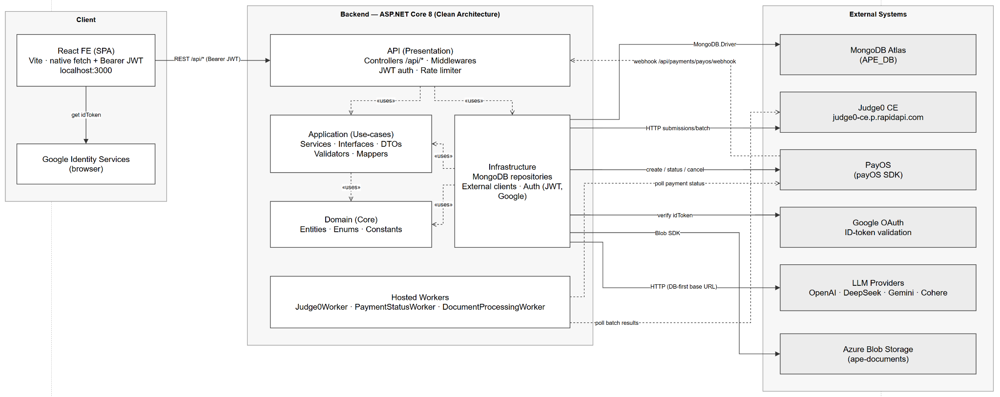
Figure 1-1. Software Architecture Diagram

1.1.1 Architectural Overview:
The system follows a client–server model with a Single Page Application (SPA) on the client side and a REST API on the server side. The backend applies Clean Architecture (Onion), organized into four layers whose dependency direction converges on the Domain layer:

API -> { Application, Infrastructure }

Infrastructure -> { Application, Domain }

Application -> Domain

Domain -> (no project dependency)

This principle keeps the Domain (core business logic) fully independent of the framework and infrastructure. Every access to the outside world (database, external clients) resides in the Infrastructure layer behind abstractions (interfaces) defined by the Application layer, in accordance with the Dependency Inversion Principle.

1.1.2 Component Descriptions:
a. React FE (Presentation — client). An SPA built with Vite and React 18 that communicates purely through the native fetch API (no axios). Every request passes through the services/http.js wrapper, which automatically attaches the Bearer JWT and refreshes the token on a 401 response. The base URL is configured through VITE_API_BASE_URL.

b. API layer (Presentation — server). The ASP.NET Core 8 host, acting as the composition root (Program.cs registers dependency injection). It contains 25 REST controllers (/api/*), a centralized error-handling middleware (ExceptionMiddleware), the AllowFrontend CORS policy, JWT Bearer authentication, a fixed-window rate limiter (for the auth group), and the hosted workers that run in the background.

c. Application layer (Application / Use-case). Contains business and orchestration services (AuthService, ExamService, CodeMentorService, the AI*Service family, etc.), DTOs, interfaces (service, repository, and external-client abstractions), validators (FluentValidation), mappers (AutoMapper), options, and business exceptions. This is where use cases are orchestrated; it holds no infrastructure details.

d. Domain layer (Domain / Core). Contains the entities persisted to MongoDB, enums, and constants. It depends only on MongoDB.Bson (for BSON mapping attributes) and references no other project, keeping the core business logic self-contained.

e. Infrastructure layer. Implements the abstractions defined by the Application layer: MongoDB repositories (Persistence), the DbContext and seeders (Data), external clients (Judge0, LLM providers, PayOS), authentication (JWT and Google), and file storage (Azure Blob). It is the only boundary that touches the outside world.

f. Hosted Workers (background). Three background services handle asynchronous tasks: Judge0Worker (polls code-grading results), PaymentStatusWorker (polls payment status), and DocumentProcessingWorker (processes and embeds documents).

1.1.3 External Systems:
No | External system | Role | Communication method
1 | MongoDB Atlas (APE_DB) | Data storage (22 collections) | MongoDB.Driver 3.9.0; client registered as Singleton; Atlas SRV connection
2 | Judge0 CE (via RapidAPI) | Code execution / grading | HTTP typed client Judge0Client; POST submissions/batch, GET submissions/batch, GET languages
3 | PayOS | Wallet top-up (payment) | REST via the payOS SDK 2.1.0 (outbound: create/get/cancel link) plus an inbound webhook POST /api/payments/payos/webhook
4 | Google OAuth | Login authentication | The backend verifies the idToken via GoogleJsonWebSignature.ValidateAsync; the frontend uses Google Identity Services
5 | LLM Providers (OpenAI, DeepSeek, Gemini, Cohere) | Question generation, mentor feedback, embeddings | HTTP typed clients; base URL resolved DB-first (read from SystemSettings); routing driven by the AIAgents collection
6 | Azure Blob Storage (ape-documents) | Source document file storage | SDK Azure.Storage.Blobs 12.23.0

1.1.4 Overall Communication Flow:
The React frontend calls the REST API through /api/* using a Bearer JWT. Controllers delegate to services in the Application layer, which call down into the Infrastructure layer to access MongoDB or external clients. For long-running tasks (code grading, payment, document processing), the request only creates a status record; the remaining work is performed asynchronously by the hosted workers, which poll and update the state. PayOS additionally calls back into the system through a webhook to confirm transactions.

1.2 Package Diagram

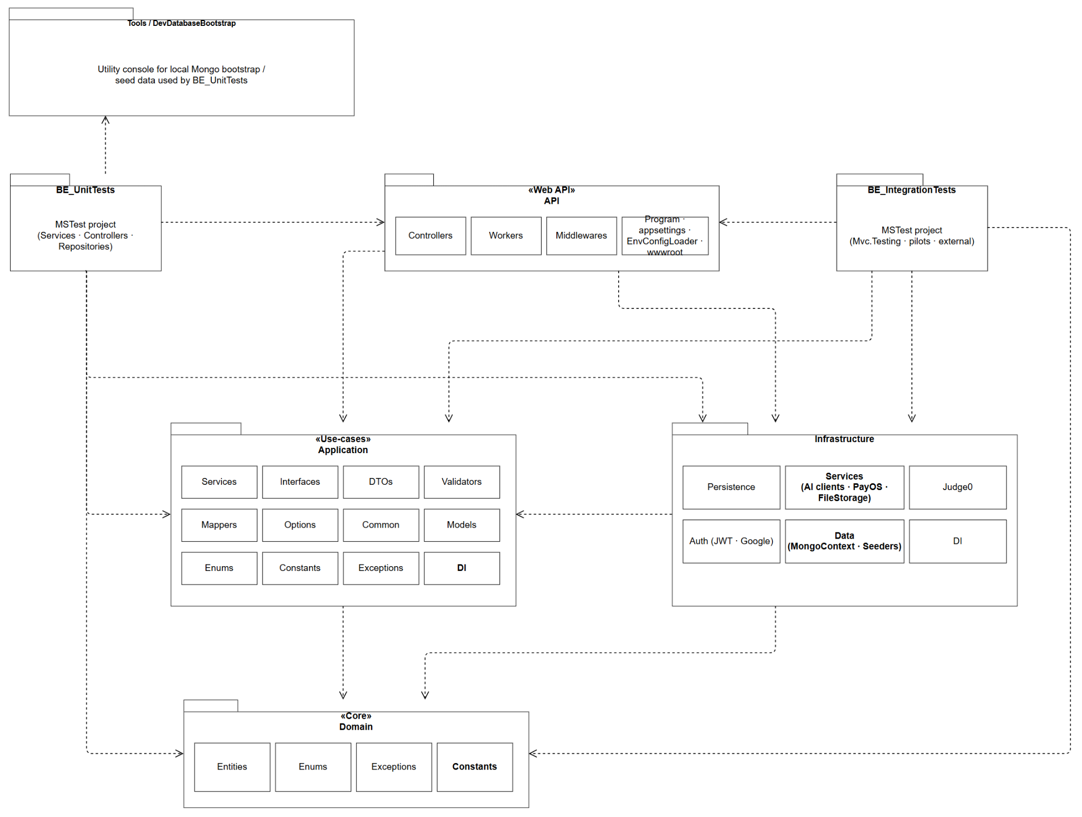
Figure 1-2. Backend Package Diagram
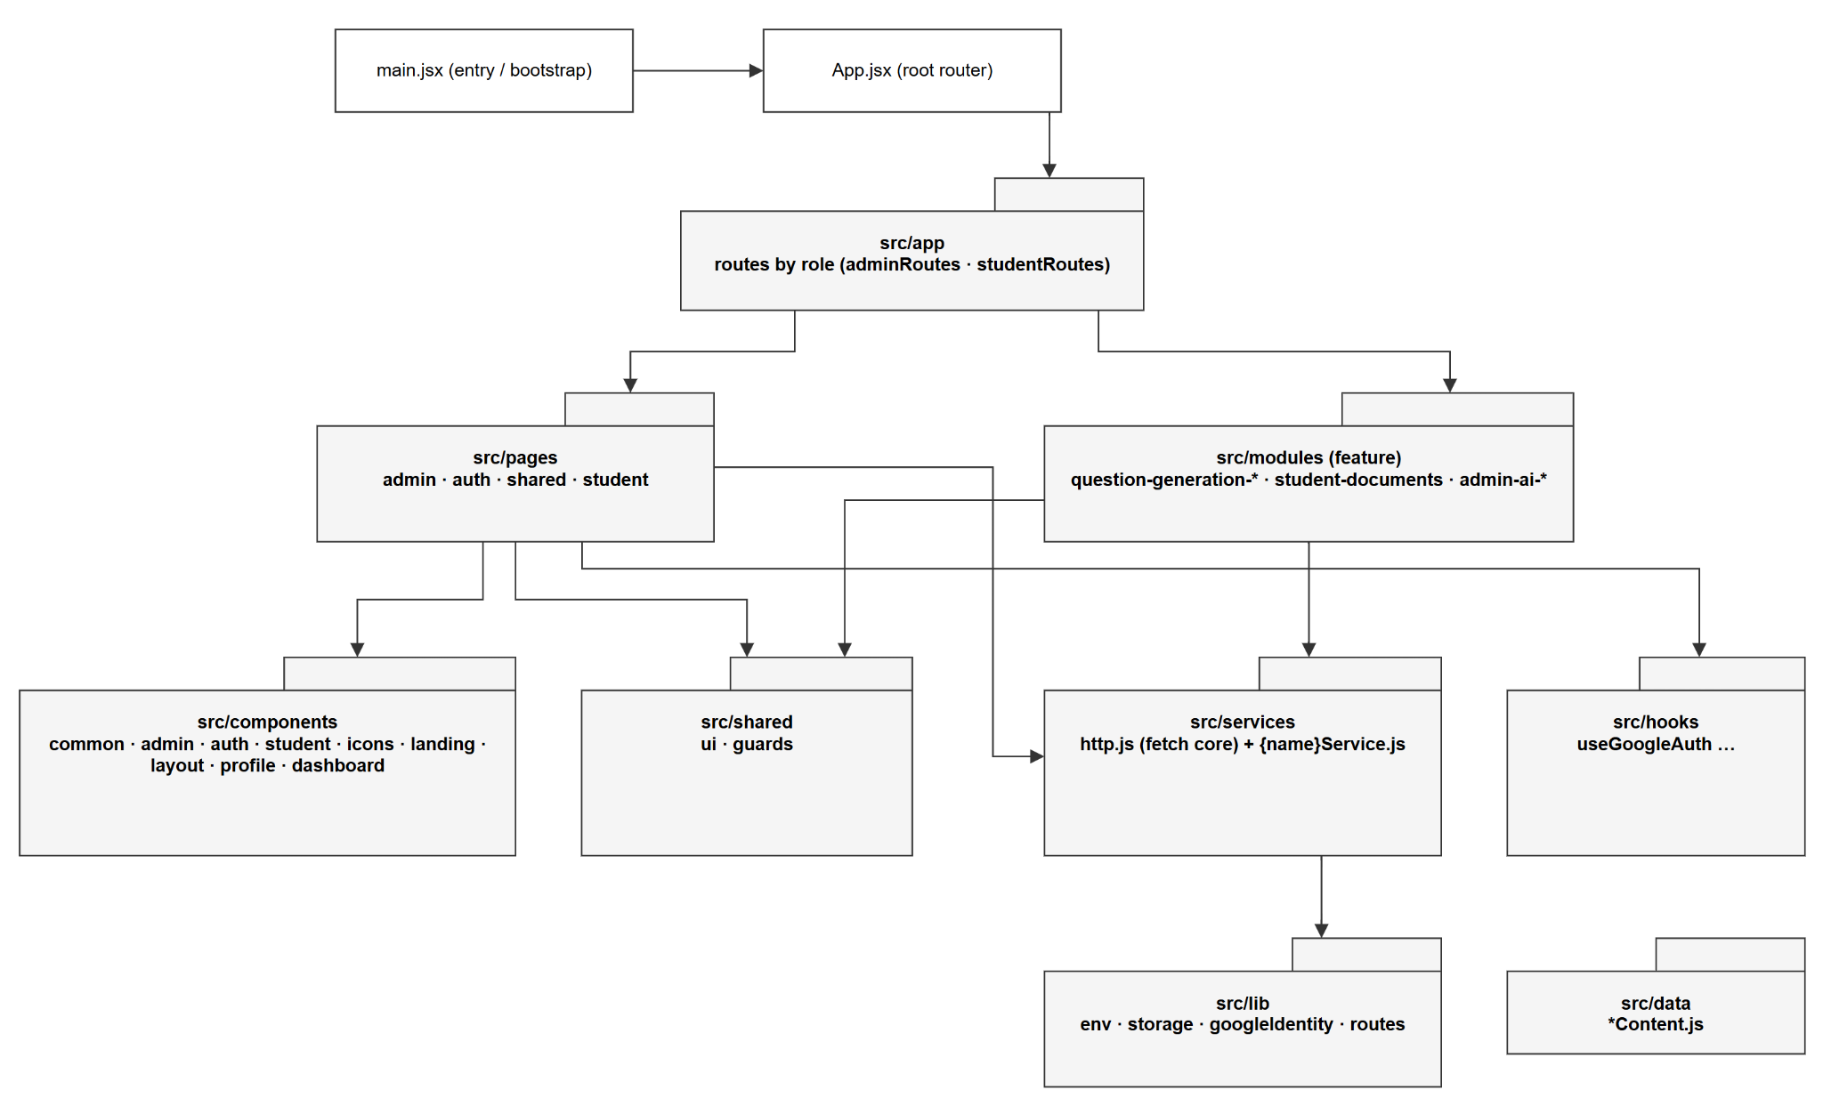
Figure 1-3. Frontend Package Diagram

1.2.1 Explanation:
The backend organizes packages by Clean Architecture layer, and the namespace mirrors the folder path (for example, Infrastructure/Judge0 maps to the namespace Infrastructure.Judge0). The frontend is organized in a modular fashion: major features live inside src/modules/* (self-contained, each with its own pages/, services/, and components/), while reusable parts reside in src/components, src/shared, src/lib, src/hooks, and src/services.

1.2.2 Package / Class Naming Conventions
Backend (.NET)

No | Convention | Description
1 | Project/namespace PascalCase | API, Application, Domain, Infrastructure; namespace mirrors the folder path
2 | Namespace vs folder exception | LLM clients live in Infrastructure/Services but use the namespace Infrastructure.AI
3 | Controller {Name}Controller | AuthController, PaymentWebhookController
4 | Interface I{Name} | IUserRepository, IPayOSService, IAITextClient
5 | Repository {Entity}Repository | Implementation {Entity}Repository plus interface I{Entity}Repository
6 | Service {Name}Service | AuthService, PayOSService, ExamService
7 | DTO {Area}Dtos / {Name}Dto | AuthDtos.cs, CreateExamDto.cs, UserProfileDto.cs
8 | Configuration suffixes | {Name}Options, {Name}Config, {Name}Settings
9 | Hosted service {Name}Worker | Judge0Worker, PaymentStatusWorker, DocumentProcessingWorker
10 | Asynchronous method …Async | CreateBatchAsync, VerifyWebhookAsync
11 | Entity PascalCase singular (mixed) | User, Course; underscore variants FE_Submission, PE_Submission
12 | Mongo collection (mixed) | Mostly PascalCase plural (Users); some UPPER_SNAKE (AI_Rule_Artifacts, AI_Credit_Transactions)
13 | One public type per file | File name equals the type name

Frontend (ReactJS)

No | Convention | Description
1 | Component/page PascalCase .jsx | Button.jsx, LoginCard.jsx, ConfirmModal.jsx
2 | Page suffix {Name}Page | DashboardPage.jsx, AdminUsersPage.jsx
3 | Component role suffixes | {Name}Card / Icon / Modal / Section / Scaffold
4 | Hook use… camelCase .js | useGoogleAuth.js, useInFlightGuard.js
5 | Service {name}Service.js camelCase | authService.js, walletService.js (plus core http.js)
6 | Route {role}Routes.jsx | adminRoutes.jsx, studentRoutes.jsx
7 | lib/utils/data camelCase .js | env.js, storage.js; data files {name}Content.js
8 | Module folders kebab-case | admin-ai-settings, question-generation-byos
9 | Barrel export index.js | In components/common, shared/ui, shared/guards, and module roots
10 | Environment variables VITE_ prefix | VITE_API_BASE_URL, VITE_GOOGLE_CLIENT_ID

1.2.3 Package Descriptions — Backend (.NET):
No | Package/Folder | Layer | Description
1 | API | BE | Web API host and composition root (Program.cs; EnvConfigurationLoader loads .env)
2 | API/Controllers | BE | REST controllers ({Name}Controller), 25 endpoint groups under /api/*
3 | API/Workers | BE | Hosted background services: DocumentProcessingWorker, Judge0Worker, PaymentStatusWorker
4 | API/Middlewares | BE | Custom middleware (ExceptionMiddleware)
5 | API/Properties | BE | Project run profiles (launchSettings.json)
6 | API/wwwroot (/uploads/documents) | BE | Static files root; locally uploaded documents
7 | API/.keys/data-protection | BE | ASP.NET Data Protection key ring (generated at runtime)
8 | Application | BE | Application layer root (packages: AutoMapper, FluentValidation, ClosedXML, PdfPig)
9 | Application/Common | BE | Cross-cutting helpers (ApiResponse, AIErrorCatalog, AIUsageAccounting, QuestionFingerprinting)
10 | Application/Constants | BE | Application constants (CourseStatus)
11 | Application/DI | BE | DI registration extension (DependencyInjection.AddApplication)
12 | Application/DTOs | BE | Request/response DTOs per feature ({Area}Dtos, {Name}Dto)
13 | Application/Enums | BE | Application-level enums (SubmissionType)
14 | Application/Exceptions | BE | Application exception types (ValidationException, UnauthorizedException, AIProviderException)
15 | Application/Interfaces | BE | Service / repository / external-client abstractions (I…)
16 | Application/Mappers | BE | Object mapping (CourseMapper)
17 | Application/Models | BE | Code-execution domain models (CodeExecutionBatchRequest, CodeExecutionResult, CodeExecutionState)
18 | Application/Options | BE | Strongly-typed options (AIOptions, PayOSOptions, AzureBlobStorageOptions)
19 | Application/Services | BE | Business/orchestration services (AuthService, ExamService, CodeMentorService, AI…Service)
20 | Application/Validators | BE | FluentValidation validators
21 | Domain | BE | Domain layer root (package: MongoDB.Bson; no project references)
22 | Domain/Entities | BE | Mongo-persisted entities (User, Course, Exam, Payment, AIAgent, KnowledgeChunk)
23 | Domain/Enums | BE | Domain enums (AIProvider, roles, statuses)
24 | Domain/Exceptions | BE | Domain exception types
25 | Infrastructure | BE | Infrastructure layer root (packages: MongoDB.Driver, Azure.Storage.Blobs, Google.Apis.Auth, JwtBearer, payOS)
26 | Infrastructure/Auth | BE | JWT (JwtTokenGenerator, JwtSettings) plus Google (GoogleAuthService, GoogleAuthConfig)
27 | Infrastructure/Data | BE | DbContext, DbInitializer, seeders (AIAgentBootstrapSeeder, AIArtifactDbSeeder), AIRuleArtifactStore
28 | Infrastructure/Data/App_Data | BE | JSON seed assets (ai-prompts.json, gatekeeper-policy.json, code-mentor-policy.json)
29 | Infrastructure/Data/App_Data/ai-rubrics | BE | AI rubric JSON assets
30 | Infrastructure/DI | BE | DI registration extensions (Judge0DependencyInjection.AddJudge0)
31 | Infrastructure/Judge0 | BE | Judge0 HTTP client (Judge0Client), options, request/response models
32 | Infrastructure/Judge0/Contracts | BE | Judge0 JSON converters/contracts (NullableIntJsonConverter)
33 | Infrastructure/Persistence | BE | MongoDB repositories ({Entity}Repository)
34 | Infrastructure/Services | BE | Service implementations: LLM clients (namespace Infrastructure.AI), PayOSService, FileStorageService, AI admin/catalog services
35 | BE_UnitTests | BE | Unit test project

1.2.4 Package Descriptions — Frontend (ReactJS src/):

No | Package/Folder | Layer | Description
1 | src/app | FE | Route definitions by role (adminRoutes.jsx, studentRoutes.jsx)
2 | src/components | FE | Shared presentational components (grouped by area)
3 | src/components/admin | FE | Admin UI (AdminGlyph, AdminScaffold)
4 | src/components/auth | FE | Auth UI (LoginCard)
5 | src/components/common | FE | Reusable primitives (Button, Avatar, Field, TextInput, Surface, Topbar, IconButton)
6 | src/components/dashboard | FE | Dashboard UI (DashboardIcon)
7 | src/components/icons | FE | SVG icon components (BellIcon, BrandMark, CreditIcon)
8 | src/components/landing | FE | Landing sections (HeroSection, FeatureCard)
9 | src/components/layout | FE | Layout pieces (AppFooter)
10 | src/components/profile | FE | Profile UI (ProfileCard, ProfileHero)
11 | src/components/student | FE | Student workspace UI (StudentScaffold, PracticeSidebar, StudentTopbar)
12 | src/data | FE | Static content/config data (landingContent.js, dashboardContent.js, profileContent.js)
13 | src/hooks | FE | Reusable React hooks (useGoogleAuth.js)
14 | src/layouts | FE | Layout components folder — currently empty (.gitkeep)
15 | src/lib | FE | Framework-agnostic utilities (env.js, storage.js, googleIdentity.js, routes.js)
16 | src/modules | FE | Feature modules (self-contained pages/, services/, components/)
17 | src/modules/admin-ai-artifacts | FE | Admin AI rule-artifact management
18 | src/modules/admin-ai-monitoring | FE | Admin AI usage and mentor-feedback logs
19 | src/modules/admin-ai-settings | FE | Admin AI provider credentials / agents / billing configuration
20 | src/modules/admin-ai-smoke | FE | Admin AI smoke-test pages (gatekeeper, embedding, code mentor)
21 | src/modules/question-generation-byos | FE | "Bring your own source" question generation
22 | src/modules/question-generation-shared | FE | Shared question-generation UI and services
23 | src/modules/question-generation-system | FE | System-source question generation
24 | src/modules/student-documents | FE | Student document upload / extraction draft
25 | src/pages | FE | Top-level route pages by role
26 | src/pages/admin | FE | Admin pages (dashboard, users, courses, questions, analytics)
27 | src/pages/auth | FE | Auth pages (LoginPage)
28 | src/pages/shared | FE | Cross-role pages (DataApprovalPreviewPage)
29 | src/pages/student | FE | Student pages (dashboard, practice, wallet, profile, leaderboard)
30 | src/services | FE | API client modules (http.js core fetch wrapper plus per-domain {name}Service.js)
31 | src/shared | FE | Shared cross-cutting UI/logic (guards, ui)
32 | src/shared/guards | FE | Navigation/form guard hooks (useInFlightGuard, useBeforeUnloadGuard, useLockedFormSnapshot)
33 | src/shared/ui | FE | Shared widgets (ConfirmModal, ToastNotification, InFlightNotice)
34 | src/store | FE | State-store folder — currently empty (.gitkeep); no global store implemented
35 | src/utils | FE | Utilities folder — currently empty (.gitkeep)

1.3 Database Design

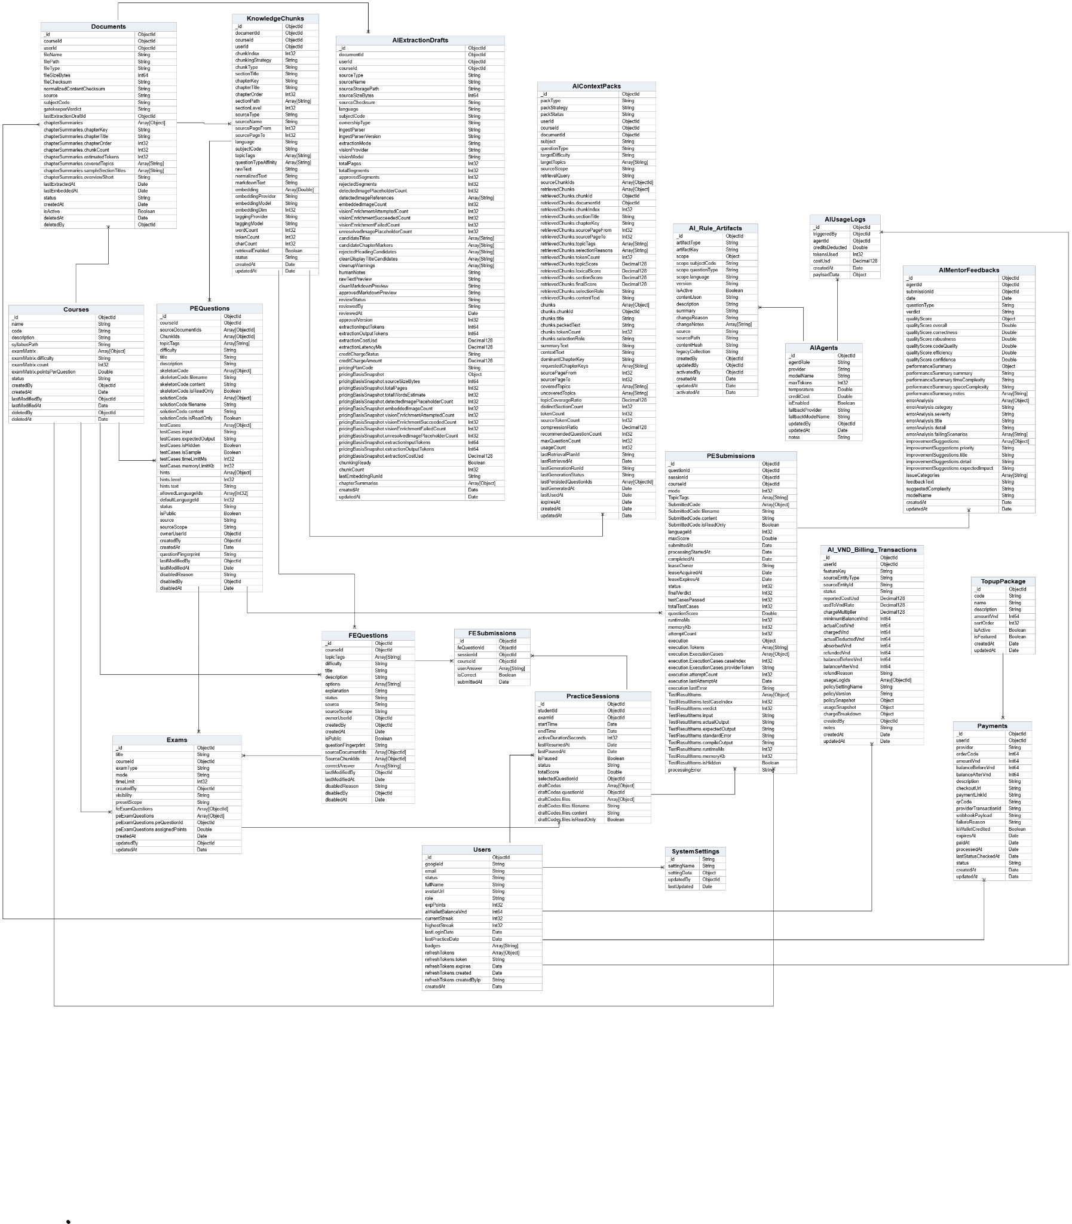
Figure 1-3. Database Schema

1.3.1 User
No | Field | PK | FK | UN | NN | Description
1 | Id | x |  | x | x | Primary identifier of the User document.
2 | GoogleId |  |  | x |  | Stores the unique Google account identifier when social login is used.
3 | Email |  |  | x | x | Stores the unique email address of the user.
4 | Status |  |  |  | x | Stores the current status of the document.
5 | FullName |  |  |  | x | Stores the full name of the user.
6 | AvatarUrl |  |  |  |  | Stores the avatar URL.
7 | Role |  |  |  | x | Stores the user role.
8 | ExpPoints |  |  |  | x | Stores exp points.
9 | AiWalletBalanceVnd |  |  |  | x | Stores the current AI wallet balance in VND.
10 | CurrentStreak |  |  |  | x | Stores current streak.
11 | HighestStreak |  |  |  | x | Stores highest streak.
12 | LastLoginDate |  |  |  |  | Stores last login date.
13 | LastPracticeDate |  |  |  |  | Stores last practice date.
14 | Badges |  |  |  | x | Stores a list of badges values.
15 | RefreshTokens |  |  |  | x | Stores active refresh token records for the user.
16 | CreatedAt |  |  |  | x | Stores the UTC timestamp when the document was created.

1.3.2 Course
No | Field | PK | FK | UN | NN | Description
1 | Id | x |  | x | x | Primary identifier of the Course document.
2 | Name |  |  |  | x | Stores the display name.
3 | Code |  |  | x | x | Stores the business code used to identify the record.
4 | Description |  |  |  |  | Stores the description or explanatory text.
5 | SyllabusPath |  |  |  |  | Stores syllabus path.
6 | ExamMatrix |  |  |  |  | Stores a list of exam matrix values.
7 | Status |  |  |  | x | Stores the current status of the document.
8 | CreatedBy |  |  |  |  | Stores the identifier of the user who created the record.
9 | CreatedAt |  |  |  |  | Stores the UTC timestamp when the document was created.
10 | LastModifiedBy |  |  |  |  | Stores last modified by.
11 | LastModifiedAt |  |  |  |  | Stores the last recorded UTC timestamp for this activity.
12 | DeletedBy |  |  |  |  | Stores the identifier of the user who deleted the record.
13 | DeletedAt |  |  |  |  | Stores the UTC timestamp when the document was soft-deleted.

1.3.3 Exam
No | Field | PK | FK | UN | NN | Description
1 | Id | x |  | x | x | Primary identifier of the Exam document.
2 | Title |  |  |  | x | Stores the title.
3 | CourseId |  | x |  | x | References the related course document. FK -> Courses.
4 | ExamType |  |  |  | x | Stores exam type.
5 | Mode |  |  |  | x | Stores mode.
6 | TimeLimit |  |  |  |  | Stores time limit.
7 | CreatedBy |  |  |  | x | Stores the identifier of the user who created the record.
8 | Visibility |  |  |  | x | Stores visibility.
9 | PresetScope |  |  |  | x | Stores preset scope.
10 | FeExamQuestions |  |  |  | x | Stores a list of fe exam questions values.
11 | PeExamQuestions |  |  |  | x | Stores a list of pe exam questions values.
12 | CreatedAt |  |  |  | x | Stores the UTC timestamp when the document was created.
13 | UpdatedBy |  |  |  |  | Stores the identifier of the user who last updated the record.
14 | UpdatedAt |  |  |  |  | Stores the UTC timestamp when the document was last updated.

1.3.4 Practice Questions
No | Field | PK | FK | UN | NN | Description
1 | Id | x |  | x | x | Primary identifier of the PracticeSession document.
2 | StudentId |  | x |  | x | References the student user document. FK -> Users.
3 | ExamId |  | x |  | x | References the related exam document. FK -> Exams.
4 | StartTime |  |  |  | x | Stores start time.
5 | EndTime |  |  |  |  | Stores end time.
6 | ActiveDurationSeconds |  |  |  | x | Stores active duration seconds.
7 | LastResumedAt |  |  |  |  | Stores the last recorded UTC timestamp for this activity.
8 | LastPausedAt |  |  |  |  | Stores the last recorded UTC timestamp for this activity.
9 | IsPaused |  |  |  | x | Boolean flag describing the state of this record.
10 | Status |  |  |  | x | Stores the current status of the document.
11 | TotalScore |  |  |  | x | Stores total score.
12 | SelectedQuestionId |  | x |  |  | Stores the identifier of the related selected question. FK -> FEQuestions/PEQuestions.
13 | DraftCodes |  |  |  | x | Stores a list of draft codes values.

1.3.5 FEQuestions
No | Field | PK | FK | UN | NN | Description
1 | Id | x |  | x | x | Primary identifier of the FEQuestion document.
2 | CourseId |  | x |  | x | References the related course document. FK -> Courses.
3 | TopicTags |  |  |  | x | Stores topic tags used for classification and filtering.
4 | Difficulty |  |  |  | x | Stores difficulty.
5 | Title |  |  |  | x | Stores the title.
6 | Description |  |  |  | x | Stores the description or explanatory text.
7 | Options |  |  |  | x | Stores a list of options values.
8 | Explanation |  |  |  |  | Stores explanation.
9 | Status |  |  |  | x | Stores the current status of the document.
10 | Source |  |  |  | x | Stores source.
11 | SourceScope |  |  |  | x | Stores source scope.
12 | OwnerUserId |  | x |  |  | Stores the identifier of the related owner user. FK -> Users.
13 | CreatedBy |  | x |  |  | Stores the identifier of the user who created the record. FK -> Users.
14 | CreatedAt |  |  |  | x | Stores the UTC timestamp when the document was created.
15 | IsPublic |  |  |  | x | Indicates whether the item is visible to public/student users.
16 | QuestionFingerprint |  |  |  |  | Stores question fingerprint.
17 | SourceDocumentIds |  | x |  | x | Stores related source document identifiers. FK -> Documents.
18 | LegacySourceChunkIds |  | x |  | x | Stores a list of related legacy source chunk identifiers. FK -> KnowledgeChunks.
19 | CorrectAnswer |  |  |  | x | Stores the correct answer value(s).
20 | LastModifiedBy |  | x |  |  | Stores last modified by. FK -> Users.
21 | LastModifiedAt |  |  |  |  | Stores the last recorded UTC timestamp for this activity.
22 | DisabledReason |  |  |  |  | Stores disabled reason.
23 | DisabledBy |  | x |  |  | Stores disabled by. FK -> Users.
24 | DisabledAt |  |  |  |  | Stores a UTC timestamp.

1.3.6 PEQuestions
No | Field | PK | FK | UN | NN | Description
1 | Id | x |  | x | x | Primary identifier of the PEQuestion document.
2 | CourseId |  | x |  | x | References the related course document. FK -> Courses.
3 | SourceDocumentIds |  | x |  | x | Stores related source document identifiers. FK -> Documents.
4 | LegacyChunkIds |  | x |  | x | Stores a list of related legacy chunk identifiers. FK -> KnowledgeChunks.
5 | TopicTags |  |  |  | x | Stores topic tags used for classification and filtering.
6 | Difficulty |  |  |  | x | Stores difficulty.
7 | Title |  |  |  | x | Stores the title.
8 | Description |  |  |  | x | Stores the description or explanatory text.
9 | SkeletonCode |  |  |  | x | Stores a list of skeleton code values.
10 | SolutionCode |  |  |  | x | Stores a list of solution code values.
11 | TestCases |  |  |  | x | Stores a list of test cases values.
12 | Hints |  |  |  | x | Stores a list of hints values.
13 | AllowedLanguageIds |  |  |  | x | Stores a list of related allowed language identifiers.
14 | DefaultLanguageId |  |  |  | x | Stores the identifier of the related default language.
15 | Status |  |  |  | x | Stores the current status of the document.
16 | IsPublic |  |  |  | x | Indicates whether the item is visible to public/student users.
17 | Source |  |  |  | x | Stores source.
18 | SourceScope |  |  |  | x | Stores source scope.
19 | OwnerUserId |  | x |  |  | Stores the identifier of the related owner user. FK -> Users.
20 | CreatedBy |  | x |  |  | Stores the identifier of the user who created the record. FK -> Users.
21 | CreatedAt |  |  |  | x | Stores the UTC timestamp when the document was created.
22 | QuestionFingerprint |  |  |  |  | Stores question fingerprint.
23 | LastModifiedBy |  | x |  |  | Stores last modified by. FK -> Users.
24 | LastModifiedAt |  |  |  |  | Stores the last recorded UTC timestamp for this activity.
25 | DisabledReason |  |  |  |  | Stores disabled reason.
26 | DisabledBy |  | x |  |  | Stores disabled by. FK -> Users.
27 | DisabledAt |  |  |  |  | Stores a UTC timestamp.

1.3.7 FESumisstions

No | Field | PK | FK | UN | NN | Description
1 | Id | x |  | x | x | Primary identifier of the FE_Submission document.
2 | FeQuestionId |  | x |  | x | References the related FE question document. FK -> FEQuestions.
3 | SessionId |  | x |  | x | References the related practice session document. FK -> PracticeSessions.
4 | CourseId |  | x |  | x | References the related course document. FK -> Courses.
5 | UserAnswer |  |  |  | x | Stores the submitted answer value(s).
6 | IsCorrect |  |  |  | x | Boolean flag describing the state of this record.
7 | SubmittedAt |  |  |  | x | Stores a UTC timestamp.

1.3.8 PESumissions
No | Field | PK | FK | UN | NN | Description
1 | Id | x |  | x | x | Primary identifier of the PE_Submission document.
2 | QuestionId |  | x | x | x | References the related programming question document. FK -> PEQuestions.
3 | SessionId |  | x | x | x | References the related practice session document. FK -> PracticeSessions.
4 | CourseId |  | x |  |  | References the related course document. FK -> Courses.
5 | Mode |  |  |  | x | Stores mode.
6 | TopicTags |  |  |  | x | Stores topic tags used for classification and filtering.
7 | SubmittedCode |  |  |  | x | Stores a list of submitted code values.
8 | LanguageId |  |  |  | x | Stores the identifier of the related language.
9 | MaxScore |  |  |  | x | Stores max score.
10 | SubmittedAt |  |  |  | x | Stores a UTC timestamp.
11 | ProcessingStartedAt |  |  |  |  | Stores a UTC timestamp.
12 | CompletedAt |  |  |  |  | Stores a UTC timestamp.
13 | LeaseOwner |  |  |  |  | Stores lease owner.
14 | LeaseAcquiredAt |  |  |  |  | Stores a UTC timestamp.
15 | LeaseExpiresAt |  |  |  |  | Stores a UTC timestamp.
16 | Status |  |  |  | x | Stores the current status of the document.
17 | FinalVerdict |  |  |  |  | Stores final verdict.
18 | TestCasesPassed |  |  |  | x | Stores test cases passed.
19 | TotalTestCases |  |  |  | x | Stores total test cases.
20 | QuestionScore |  |  |  | x | Stores question score.
21 | RuntimeMs |  |  |  | x | Stores runtime ms.
22 | MemoryKb |  |  |  | x | Stores memory kb.
23 | AttemptCount |  |  | x | x | Stores attempt count.
24 | Execution |  |  |  | x | Stores execution.
25 | TestResultItems |  |  |  | x | Stores a list of test result items values.
26 | ProcessingError |  |  |  |  | Stores processing error.

1.3.9 Documents
No | Field | PK | FK | UN | NN | Description
1 | Id | x |  | x | x | Primary identifier of the Document document.
2 | CourseId |  | x |  | x | References the related course document. FK -> Courses.
3 | UserId |  | x |  | x | References the related user document. FK -> Users.
4 | FileName |  |  |  | x | Stores the original file name.
5 | FilePath |  |  |  | x | Stores the physical or object-storage path of the file.
6 | FileType |  |  |  | x | Stores the file extension or MIME-related type.
7 | FileSizeBytes |  |  |  | x | Stores the file size in bytes.
8 | FileChecksum |  |  |  |  | Stores file checksum.
9 | NormalizedContentChecksum |  |  |  |  | Stores normalized content checksum.
10 | Source |  |  |  |  | Stores source.
11 | SubjectCode |  |  |  |  | Stores subject code.
12 | GatekeeperVerdict |  |  |  |  | Stores gatekeeper verdict.
13 | LastExtractionDraftId |  | x |  |  | Stores the identifier of the related last extraction draft. FK -> AIExtractionDrafts.
14 | ChapterSummaries |  |  |  | x | Stores a list of chapter summaries values.
15 | LastExtractedAt |  |  |  |  | Stores the last recorded UTC timestamp for this activity.
16 | LastEmbeddedAt |  |  |  |  | Stores the last recorded UTC timestamp for this activity.
17 | Status |  |  |  | x | Stores the current status of the document.
18 | CreatedAt |  |  |  | x | Stores the UTC timestamp when the document was created.
19 | IsActive |  |  |  | x | Indicates whether the document is active and available for use.
20 | DeletedAt |  |  |  |  | Stores the UTC timestamp when the document was soft-deleted.
21 | DeletedBy |  | x |  |  | Stores the identifier of the user who deleted the record. FK -> Users.

1.3.10 AIExtractionDrafts
No | Field | PK | FK | UN | NN | Description
1 | Id | x |  | x | x | Primary identifier of the AIExtractionDraft document.
2 | DocumentId |  | x |  | x | References the related document record. FK -> Documents.
3 | UserId |  | x |  | x | References the related user document. FK -> Users.
4 | CourseId |  | x |  |  | References the related course document. FK -> Courses.
5 | SourceType |  |  |  | x | Stores source type.
6 | SourceName |  |  |  | x | Stores source name.
7 | SourceStoragePath |  |  |  |  | Stores source storage path.
8 | SourceSizeBytes |  |  |  | x | Stores source size bytes.
9 | SourceChecksum |  |  |  | x | Stores source checksum.
10 | Language |  |  |  | x | Stores language.
11 | SubjectCode |  |  |  | x | Stores subject code.
12 | OwnershipType |  |  |  | x | Stores ownership type.
13 | IngestParser |  |  |  | x | Stores ingest parser.
14 | IngestParserVersion |  |  |  | x | Stores ingest parser version.
15 | ExtractionMode |  |  |  | x | Stores extraction mode.
16 | VisionProvider |  |  |  |  | Stores vision provider.
17 | VisionModel |  |  |  |  | Stores vision model.
18 | TotalPages |  |  |  | x | Stores total pages.
19 | TotalSegments |  |  |  | x | Stores total segments.
20 | ApprovedSegments |  |  |  | x | Stores approved segments.
21 | RejectedSegments |  |  |  | x | Stores rejected segments.
22 | DetectedImagePlaceholderCount |  |  |  | x | Stores detected image placeholder count.
23 | DetectedImageReferences |  |  |  | x | Stores a list of detected image references values.
24 | EmbeddedImageCount |  |  |  | x | Stores embedded image count.
25 | VisionEnrichmentAttemptedCount |  |  |  | x | Stores vision enrichment attempted count.
26 | VisionEnrichmentSucceededCount |  |  |  | x | Stores vision enrichment succeeded count.
27 | VisionEnrichmentFailedCount |  |  |  | x | Stores vision enrichment failed count.
28 | UnresolvedImagePlaceholderCount |  |  |  | x | Stores unresolved image placeholder count.
29 | CandidateTitles |  |  |  | x | Stores a list of candidate titles values.
30 | CandidateChapterMarkers |  |  |  | x | Stores a list of candidate chapter markers values.
31 | RejectedHeadingCandidates |  |  |  | x | Stores a list of rejected heading candidates values.
32 | CleanDisplayTitleCandidates |  |  |  | x | Stores a list of clean display title candidates values.
33 | CleanupWarnings |  |  |  | x | Stores a list of cleanup warnings values.
34 | HumanNotes |  |  |  |  | Stores human notes.
35 | RawTextPreview |  |  |  |  | Stores raw text preview.
36 | CleanMarkdownPreview |  |  |  |  | Stores clean markdown preview.
37 | ApprovedMarkdownPreview |  |  |  |  | Stores approved markdown preview.
38 | ReviewStatus |  |  |  | x | Stores review status.
39 | ReviewedBy |  | x |  |  | Stores reviewed by. FK -> Users.
40 | ReviewedAt |  |  |  |  | Stores a UTC timestamp.
41 | ApprovalVersion |  |  |  | x | Stores approval version.
42 | ExtractionInputTokens |  |  |  | x | Stores extraction input tokens.
43 | ExtractionOutputTokens |  |  |  | x | Stores extraction output tokens.
44 | ExtractionCostUsd |  |  |  | x | Stores extraction cost usd.
45 | ExtractionLatencyMs |  |  |  | x | Stores extraction latency ms.
46 | CreditChargeStatus |  |  |  | x | Stores credit charge status.
47 | CreditChargeAmount |  |  |  | x | Stores credit charge amount.
48 | PricingPlanCode |  |  |  |  | Stores pricing plan code.
49 | PricingBasisSnapshot |  |  |  | x | Stores pricing basis snapshot.
50 | ChunkingReady |  |  |  | x | Stores chunking ready.
51 | ChunkCount |  |  |  | x | Stores chunk count.
52 | LastEmbeddingRunId |  |  |  |  | Stores the identifier of the related last embedding run.
53 | ChapterSummaries |  |  |  | x | Stores a list of chapter summaries values.
54 | CreatedAt |  |  |  | x | Stores the UTC timestamp when the document was created.
55 | UpdatedAt |  |  |  | x | Stores the UTC timestamp when the document was last updated.

1.3.11 AIContextPacks
No | Field | PK | FK | UN | NN | Description
1 | Id | x |  | x | x | Primary identifier of the AIContextPack document.
2 | PackType |  |  |  | x | Stores pack type.
3 | PackStrategy |  |  |  | x | Stores pack strategy.
4 | PackStatus |  |  |  | x | Stores pack status.
5 | UserId |  | x |  | x | References the related user document. FK -> Users.
6 | CourseId |  | x |  |  | References the related course document. FK -> Courses.
7 | DocumentId |  | x |  |  | References the related document record. FK -> Documents.
8 | Subject |  |  |  | x | Stores subject.
9 | QuestionType |  |  |  | x | Stores question type.
10 | TargetDifficulty |  |  |  | x | Stores target difficulty.
11 | TargetTopics |  |  |  | x | Stores a list of target topics values.
12 | SourceScope |  |  |  | x | Stores source scope.
13 | RetrievalQuery |  |  |  |  | Stores retrieval query.
14 | SourceChunkIds |  | x |  | x | Stores a list of related source chunk identifiers. FK -> KnowledgeChunks.
15 | RetrievedChunks |  |  |  | x | Stores a list of retrieved chunks values.
16 | Chunks |  |  |  | x | Stores a list of chunks values.
17 | SummaryText |  |  |  | x | Stores summary text.
18 | ContextText |  |  |  | x | Stores context text.
19 | DominantChapterKey |  |  |  |  | Stores dominant chapter key.
20 | RequestedChapterKeys |  |  |  | x | Stores a list of requested chapter keys values.
21 | SourcePageFrom |  |  |  |  | Stores source page from.
22 | SourcePageTo |  |  |  |  | Stores source page to.
23 | CoveredTopics |  |  |  | x | Stores a list of covered topics values.
24 | UncoveredTopics |  |  |  | x | Stores a list of uncovered topics values.
25 | TopicCoverageRatio |  |  |  | x | Stores topic coverage ratio.
26 | DistinctSectionCount |  |  |  | x | Stores distinct section count.
27 | TokenCount |  |  |  | x | Stores token count.
28 | SourceTokenCount |  |  |  | x | Stores source token count.
29 | CompressionRatio |  |  |  | x | Stores compression ratio.
30 | RecommendedQuestionCount |  |  |  | x | Stores recommended question count.
31 | MaxQuestionCount |  |  |  | x | Stores max question count.
32 | UsageCount |  |  |  | x | Stores usage count.
33 | LastRetrievalPlanId |  |  |  |  | Stores the identifier of the related last retrieval plan.
34 | LastRetrievedAt |  |  |  |  | Stores the last recorded UTC timestamp for this activity.
35 | LastGenerationRunId |  |  |  |  | Stores the identifier of the related last generation run.
36 | LastGenerationStatus |  |  |  |  | Stores last generation status.
37 | LastPersistedQuestionIds |  | x |  | x | Stores a list of related last persisted question identifiers. FK -> FEQuestions/PEQuestions.
38 | LastGeneratedAt |  |  |  |  | Stores the last recorded UTC timestamp for this activity.
39 | LastUsedAt |  |  |  |  | Stores the last recorded UTC timestamp for this activity.
40 | ExpiresAt |  |  |  |  | Stores a UTC timestamp.
41 | CreatedAt |  |  |  | x | Stores the UTC timestamp when the document was created.
42 | UpdatedAt |  |  |  | x | Stores the UTC timestamp when the document was last updated.

1.3.12 KnowledgeChunks
No | Field | PK | FK | UN | NN | Description
1 | Id | x |  | x | x | Primary identifier of the KnowledgeChunk document.
2 | DocumentId |  | x |  | x | References the related document record. FK -> Documents.
3 | CourseId |  | x |  | x | References the related course document. FK -> Courses.
4 | UserId |  | x |  | x | References the related user document. FK -> Users.
5 | ChunkIndex |  |  |  | x | Stores chunk index.
6 | ChunkingStrategy |  |  |  | x | Stores chunking strategy.
7 | ChunkType |  |  |  | x | Stores chunk type.
8 | SectionTitle |  |  |  |  | Stores section title.
9 | ChapterKey |  |  |  |  | Stores chapter key.
10 | ChapterTitle |  |  |  |  | Stores chapter title.
11 | ChapterOrder |  |  |  |  | Stores chapter order.
12 | SectionPath |  |  |  | x | Stores a list of section path values.
13 | SectionLevel |  |  |  |  | Stores section level.
14 | SourceType |  |  |  | x | Stores source type.
15 | SourceName |  |  |  |  | Stores source name.
16 | SourcePageFrom |  |  |  |  | Stores source page from.
17 | SourcePageTo |  |  |  |  | Stores source page to.
18 | Language |  |  |  | x | Stores language.
19 | SubjectCode |  |  |  |  | Stores subject code.
20 | TopicTags |  |  |  | x | Stores topic tags used for classification and filtering.
21 | QuestionTypeAffinity |  |  |  | x | Stores a list of question type affinity values.
22 | RawText |  |  |  | x | Stores raw text.
23 | NormalizedText |  |  |  |  | Stores normalized text.
24 | MarkdownText |  |  |  |  | Stores markdown text.
25 | Embedding |  |  |  | x | Stores a list of embedding values.
26 | EmbeddingProvider |  |  |  |  | Stores embedding provider.
27 | EmbeddingModel |  |  |  |  | Stores embedding model.
28 | EmbeddingDim |  |  |  |  | Stores embedding dim.
29 | TaggingProvider |  |  |  |  | Stores tagging provider.
30 | TaggingModel |  |  |  |  | Stores tagging model.
31 | WordCount |  |  |  | x | Stores word count.
32 | TokenCount |  |  |  | x | Stores token count.
33 | CharCount |  |  |  | x | Stores char count.
34 | RetrievalEnabled |  |  |  | x | Stores retrieval enabled.
35 | Status |  |  |  | x | Stores the current status of the document.
36 | CreatedAt |  |  |  | x | Stores the UTC timestamp when the document was created.
37 | UpdatedAt |  |  |  | x | Stores the UTC timestamp when the document was last updated.

1.3.13 Payments
No | Field | PK | FK | UN | NN | Description
1 | Id | x |  | x | x | Primary identifier of the Payment document.
2 | UserId |  | x |  | x | References the related user document. FK -> Users.
3 | Provider |  |  |  | x | Stores the external provider name.
4 | OrderCode |  |  | x | x | Stores the unique payment order code from the payment provider.
5 | AmountVnd |  |  |  | x | Stores the amount in VND.
6 | BalanceBeforeVnd |  |  |  | x | Stores the wallet balance before the transaction.
7 | BalanceAfterVnd |  |  |  | x | Stores the wallet balance after the transaction.
8 | Description |  |  |  | x | Stores the description or explanatory text.
9 | PackageId |  | x |  |  | Stores the identifier of the related package. FK -> TopupPackages.
10 | PackageCode |  |  |  |  | Stores package code.
11 | PackageName |  |  |  |  | Stores package name.
12 | CheckoutUrl |  |  |  |  | Stores checkout url.
13 | PaymentLinkId |  |  |  |  | Stores the provider payment link identifier.
14 | QrCode |  |  |  |  | Stores qr code.
15 | ProviderTransactionId |  |  |  |  | Stores the identifier of the related provider transaction.
16 | WebhookPayload |  |  |  |  | Stores webhook payload.
17 | FailureReason |  |  |  |  | Stores failure reason.
18 | IsWalletCredited |  |  |  | x | Indicates whether wallet balance has already been credited.
19 | ExpiresAt |  |  |  |  | Stores a UTC timestamp.
20 | PaidAt |  |  |  |  | Stores a UTC timestamp.
21 | ProcessedAt |  |  |  |  | Stores a UTC timestamp.
22 | LastStatusCheckedAt |  |  |  |  | Stores the last recorded UTC timestamp for this activity.
23 | Status |  |  |  | x | Stores the current status of the document.
24 | CreatedAt |  |  |  | x | Stores the UTC timestamp when the document was created.
25 | UpdatedAt |  |  |  |  | Stores the UTC timestamp when the document was last updated.

1.3.14 TopupPackages
No | Field | PK | FK | UN | NN | Description
1 | Id | x |  | x | x | Primary identifier of the TopupPackage document.
2 | Code |  |  | x | x | Stores the business code used to identify the record.
3 | Name |  |  |  | x | Stores the display name.
4 | Description |  |  |  |  | Stores the description or explanatory text.
5 | AmountVnd |  |  |  | x | Stores the amount in VND.
6 | SortOrder |  |  |  | x | Controls the display order in the UI.
7 | IsActive |  |  |  | x | Indicates whether the document is active and available for use.
8 | IsFeatured |  |  |  | x | Indicates whether the package should be highlighted in the UI.
9 | CreatedAt |  |  |  | x | Stores the UTC timestamp when the document was created.
10 | UpdatedAt |  |  |  | x | Stores the UTC timestamp when the document was last updated.

1.3.15 DailyPracticeSummaries
No | Field | PK | FK | UN | NN | Description
1 | Id | x |  | x | x | Primary identifier of the DailyPracticeSummary document.
2 | UserId |  | x |  | x | References the related user document. FK -> Users.
3 | Date |  |  |  | x | Stores date.
4 | TotalFECorrect |  |  |  | x | Stores total fecorrect.
5 | TotalPEPassed |  |  |  | x | Stores total pepassed.
6 | TotalSessionsTaken |  |  |  | x | Stores total sessions taken.
7 | SessionDetails |  |  |  | x | Stores a list of session details values.

1.3.16 SystemSettings
No | Field | PK | FK | UN | NN | Description
1 | Id | x |  | x | x | Primary identifier of the SystemSetting document.
2 | SettingName |  |  | x | x | Stores the logical setting name.
3 | SettingData |  |  |  |  | Stores the serialized setting payload.
4 | UpdatedBy |  | x |  | x | Stores the identifier of the user who last updated the record. FK -> Users.
5 | LastUpdated |  |  |  | x | Stores the UTC timestamp of the last update.

1.3.17 Reports
No | Field | PK | FK | UN | NN | Description
1 | Id | x |  | x | x | Primary identifier of the Report document.
2 | UserId |  | x |  | x | References the related user document. FK -> Users.
3 | TargetType |  |  |  | x | Stores the target entity type.
4 | TargetId |  | x |  |  | References the target object being reported. FK -> Polymorphic target.
5 | IssueCategory |  |  |  | x | Stores the issue category selected by the reporter.
6 | Description |  |  |  |  | Stores the description or explanatory text.
7 | Status |  |  |  | x | Stores the current status of the document.
8 | CreatedAt |  |  |  | x | Stores the UTC timestamp when the document was created.

1.3.18 AIAgents
No | Field | PK | FK | UN | NN | Description
1 | Id | x |  | x | x | Primary identifier of the AIAgent document.
2 | AgentRole |  |  |  | x | Stores agent role.
3 | Provider |  |  |  | x | Stores the external provider name.
4 | ModelName |  |  |  | x | Stores the AI model name.
5 | MaxTokens |  |  |  |  | Stores max tokens.
6 | Temperature |  |  |  |  | Stores temperature.
7 | CreditCost |  |  |  | x | Stores credit cost.
8 | IsEnabled |  |  |  | x | Indicates whether the item is enabled for runtime usage.
9 | FallbackProvider |  |  |  |  | Stores fallback provider.
10 | FallbackModelName |  |  |  |  | Stores fallback model name.
11 | UpdatedBy |  | x |  |  | Stores the identifier of the user who last updated the record. FK -> Users.
12 | UpdatedAt |  |  |  | x | Stores the UTC timestamp when the document was last updated.
13 | Notes |  |  |  |  | Stores additional notes.

1.3.19 AIRuleArtifacts
No | Field | PK | FK | UN | NN | Description
1 | Id | x |  | x | x | Primary identifier of the AIRuleArtifact document.
2 | ArtifactType |  |  | x | x | Stores the artifact category.
3 | ArtifactKey |  |  | x | x | Stores the logical key of the artifact.
4 | Scope |  |  | x | x | Stores scope.
5 | Version |  |  | x | x | Stores the version label.
6 | IsActive |  |  | x | x | Indicates whether the document is active and available for use.
7 | ContentJson |  |  |  | x | Stores the full JSON payload of the artifact.
8 | Description |  |  |  |  | Stores the description or explanatory text.
9 | Summary |  |  |  |  | Stores summary.
10 | ChangeReason |  |  |  |  | Stores change reason.
11 | ChangeNotes |  |  |  | x | Stores a list of change notes values.
12 | Source |  |  |  | x | Stores source.
13 | SourcePath |  |  |  |  | Stores the source file path used to build the artifact.
14 | ContentHash |  |  | x |  | Stores the content hash used for change tracking.
15 | LegacyCollection |  |  |  |  | Stores legacy collection.
16 | CreatedBy |  | x |  |  | Stores the identifier of the user who created the record. FK -> Users.
17 | UpdatedBy |  | x |  |  | Stores the identifier of the user who last updated the record. FK -> Users.
18 | ActivatedBy |  | x |  |  | Stores activated by. FK -> Users.
19 | CreatedAt |  |  |  | x | Stores the UTC timestamp when the document was created.
20 | UpdatedAt |  |  |  | x | Stores the UTC timestamp when the document was last updated.
21 | ActivatedAt |  |  |  |  | Stores a UTC timestamp.

1.3.20 AIUsageLogs
No | Field | PK | FK | UN | NN | Description
1 | Id | x |  | x | x | Primary identifier of the AIUsageLog document.
2 | TriggeredBy |  | x |  | x | Stores triggered by. FK -> Users.
3 | AgentId |  | x |  | x | References the related AI agent document. FK -> AIAgents.
4 | CreditsDeducted |  |  |  | x | Stores credits deducted.
5 | TokensUsed |  |  |  | x | Stores tokens used.
6 | CostUsd |  |  |  | x | Stores cost usd.
7 | CreatedAt |  |  |  | x | Stores the UTC timestamp when the document was created.
8 | PayloadData |  |  |  |  | Stores payload data.

1.3.21 AI_VND_Billing_Transactions
No | Field | PK | FK | UN | NN | Description
1 | Id | x |  | x | x | Primary identifier of the AIVndBillingTransaction document.
2 | UserId |  | x |  | x | References the related user document. FK -> Users.
3 | FeatureKey |  |  |  | x | Stores feature key.
4 | SourceEntityType |  |  |  | x | Stores source entity type.
5 | SourceEntityId |  | x |  | x | Stores the identifier of the related source entity. FK -> Polymorphic source.
6 | Status |  |  |  | x | Stores the current status of the document.
7 | ReportedCostUsd |  |  |  | x | Stores reported cost usd.
8 | UsdToVndRate |  |  |  | x | Stores usd to vnd rate.
9 | ChargeMultiplier |  |  |  | x | Stores charge multiplier.
10 | MinimumBalanceVnd |  |  |  | x | Stores minimum balance vnd.
11 | ActualCostVnd |  |  |  | x | Stores actual cost vnd.
12 | ChargedVnd |  |  |  | x | Stores charged vnd.
13 | ActualDeductedVnd |  |  |  | x | Stores actual deducted vnd.
14 | AbsorbedVnd |  |  |  | x | Stores absorbed vnd.
15 | RefundedVnd |  |  |  | x | Stores refunded vnd.
16 | BalanceBeforeVnd |  |  |  | x | Stores the wallet balance before the transaction.
17 | BalanceAfterVnd |  |  |  | x | Stores the wallet balance after the transaction.
18 | RefundReason |  |  |  |  | Stores refund reason.
19 | UsageLogIds |  | x |  | x | Stores a list of related usage log identifiers. FK -> AIUsageLogs.
20 | PolicySettingName |  |  |  | x | Stores policy setting name.
21 | PolicyVersion |  |  |  | x | Stores policy version.
22 | PolicySnapshot |  |  |  |  | Stores policy snapshot.
23 | UsageSnapshot |  |  |  |  | Stores usage snapshot.
24 | ChargeBreakdown |  |  |  |  | Stores charge breakdown.
25 | CreatedBy |  | x |  | x | Stores the identifier of the user who created the record. FK -> Users.
26 | Notes |  |  |  |  | Stores additional notes.
27 | CreatedAt |  |  |  | x | Stores the UTC timestamp when the document was created.
28 | UpdatedAt |  |  |  | x | Stores the UTC timestamp when the document was last updated.

1.3.22 AIMentorFeedbacks
No | Field | PK | FK | UN | NN | Description
1 | Id | x |  | x | x | Primary identifier of the AIMentorFeedback document.
2 | AgentId |  | x |  |  | References the related AI agent document. FK -> AIAgents.
3 | SubmissionId |  | x |  | x | References the related submission document. FK -> PESubmissions/other submission source.
4 | Date |  |  |  | x | Stores date.
5 | QuestionType |  |  |  | x | Stores question type.
6 | Verdict |  |  |  |  | Stores verdict.
7 | QualityScore |  |  |  |  | Stores quality score.
8 | PerformanceSummary |  |  |  |  | Stores performance summary.
9 | ErrorAnalysis |  |  |  | x | Stores a list of error analysis values.
10 | ImprovementSuggestions |  |  |  | x | Stores a list of improvement suggestions values.
11 | IssueCategories |  |  |  | x | Boolean flag describing the state of this record.
12 | FeedbackText |  |  |  |  | Stores feedback text.
13 | SuggestedComplexity |  |  |  |  | Stores suggested complexity.
14 | ModelName |  |  |  |  | Stores the AI model name.
15 | CreatedAt |  |  |  | x | Stores the UTC timestamp when the document was created.
16 | UpdatedAt |  |  |  | x | Stores the UTC timestamp when the document was last updated.

2.1 Authentication

2.1.1 Class Diagram
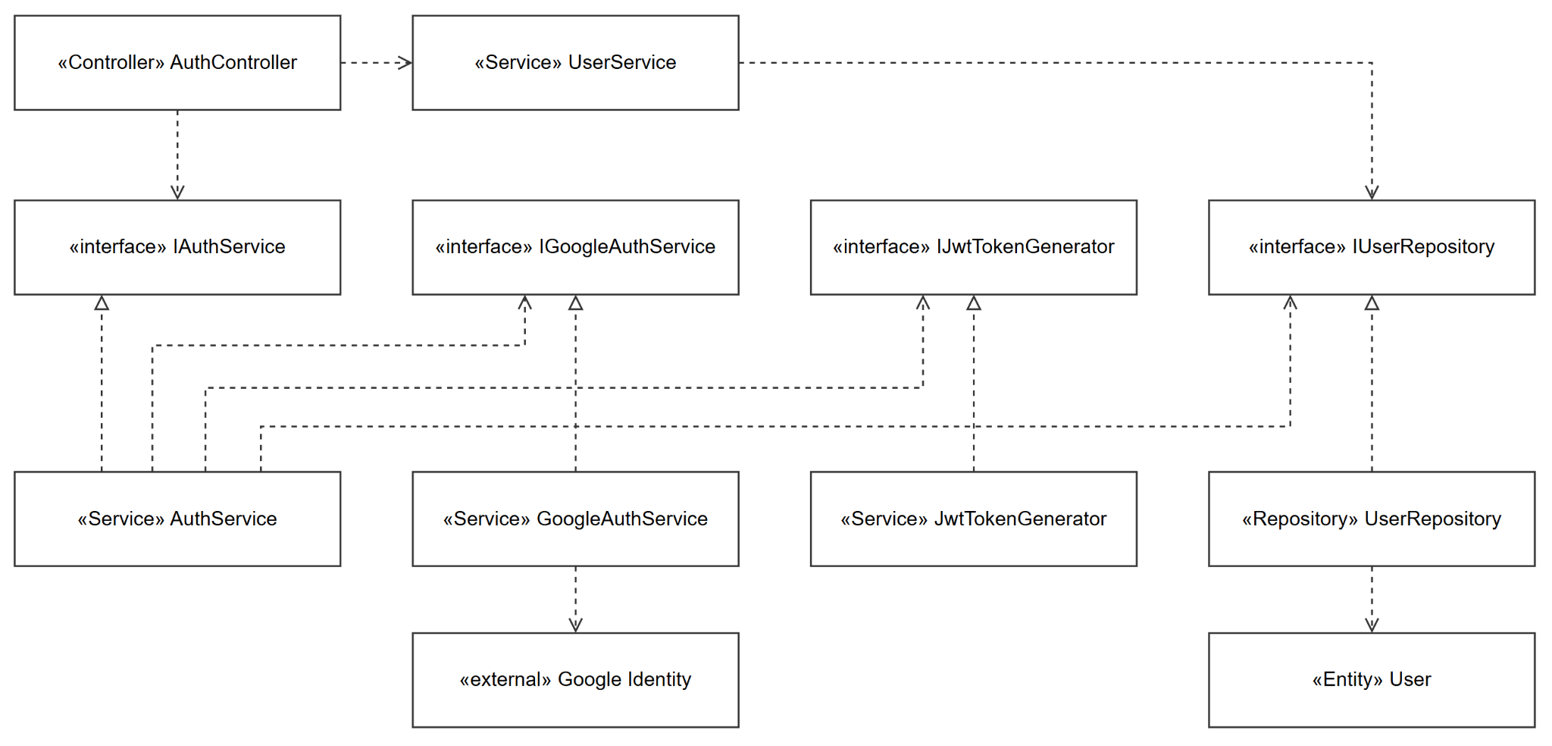
Figure 2-1-1. Authentication — Class Diagram

Class | Type | Layer | Note
AuthController | Controller | API | Routes /api/auth/{google,me,refresh}
AuthService | Service | Application | ▷ IAuthService
UserService | Service | Application | Profile / me
IGoogleAuthService → GoogleAuthService | Service (Singleton) | Infrastructure/Auth | Google ID-token verification; → IOptions<GoogleAuthConfig>
IJwtTokenGenerator → JwtTokenGenerator | Service (Singleton) | Infrastructure/Auth | JWT issuance; → IOptions<JwtSettings>
IUserRepository → UserRepository | Repository | Infrastructure | Owned here, reused across features
User (+ RefreshToken) | Entity | Domain | —
JwtSettings, GoogleAuthConfig | Options | Infrastructure/Auth | —

2.1.2 Sequence Diagram — Google Login, Refresh, Profile
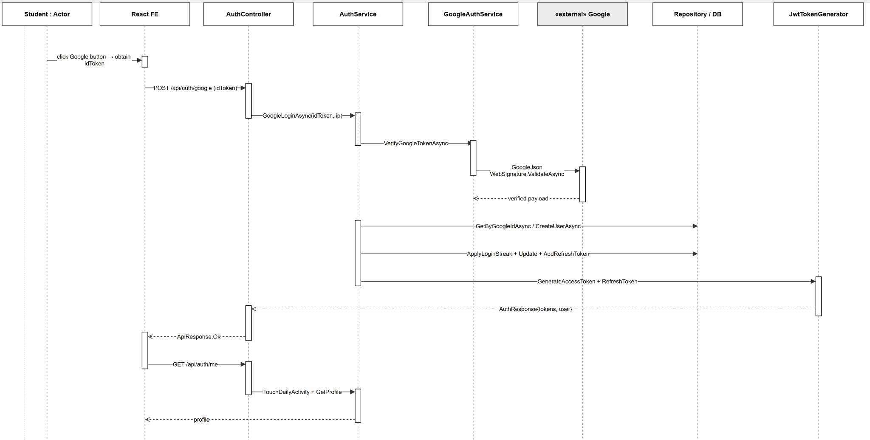
Figure 2-1-2. Authentication — Sequence Diagram

2.2 AI Wallet & Top-up

2.2.1 Class Diagram
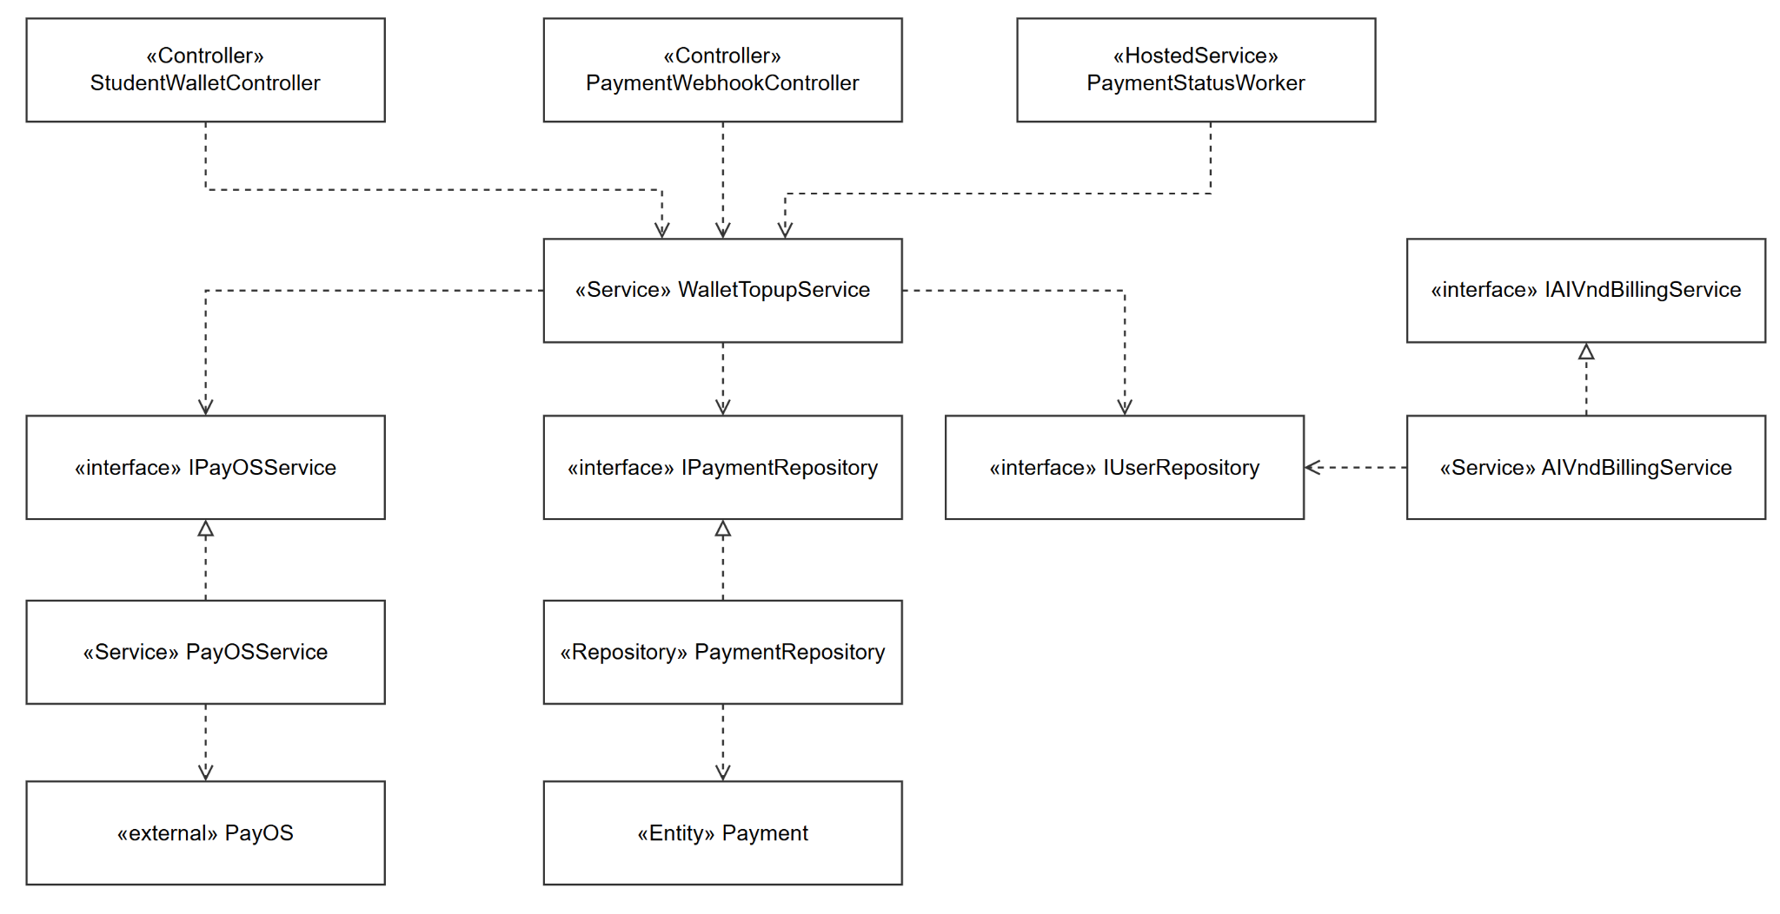
Figure 2-2-1. AI Wallet & Top-up — Class Diagram

Class | Type | Layer | Note
StudentWalletController | Controller | API | /api/student/wallet/*
PaymentWebhookController | Controller | API | POST /api/payments/payos/webhook ([AllowAnonymous])
WalletTopupService | Service | Application | Create / cancel / history / webhook
IPayOSService → PayOSService | Service | Infrastructure/Services | Wraps payOS SDK; → IOptions<PayOSOptions>
IPaymentRepository → PaymentRepository | Repository | Infrastructure | —
IAIVndBillingService → AIVndBillingService | Service | Application | VND billing; owned here, reused by AI features
IAICreditPolicyService → AICreditPolicyService | Service | Application | Credit policy (stateless)
IAIVndBillingTransactionRepository → AIVndBillingTransactionRepository | Repository | Infrastructure | —
IAICreditTransactionRepository → AICreditTransactionRepository | Repository | Infrastructure | —
PaymentStatusWorker | HostedService | API/Workers | → IServiceScopeFactory, ILogger
Payment | Entity | Domain | —

2.2.2 Sequence Diagram — Create Top-up
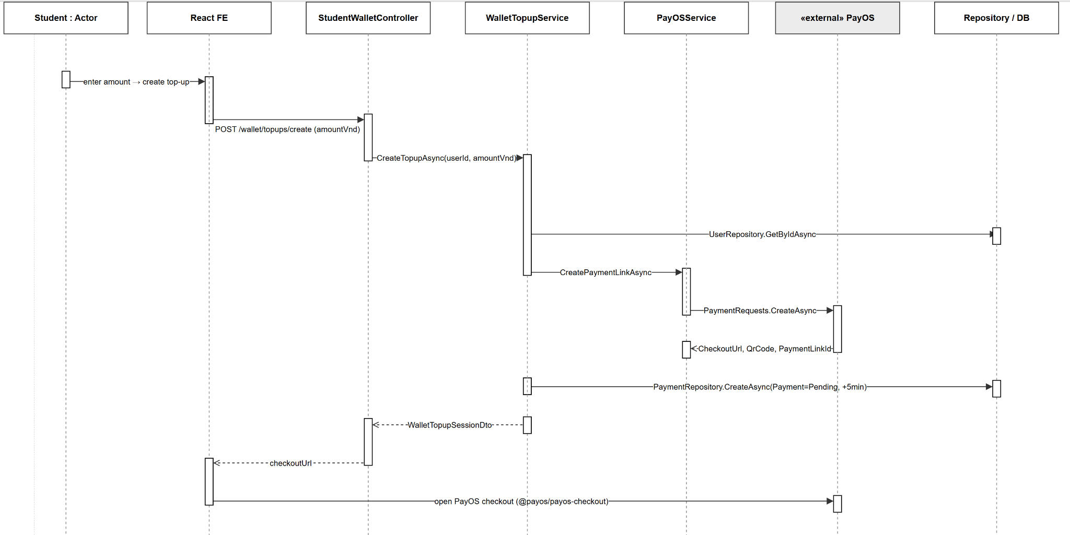
Figure 2-2-2. Create Top-up — Sequence Diagram

2.2.3 Sequence Diagram — Payment Confirmation (Webhook and Polling)
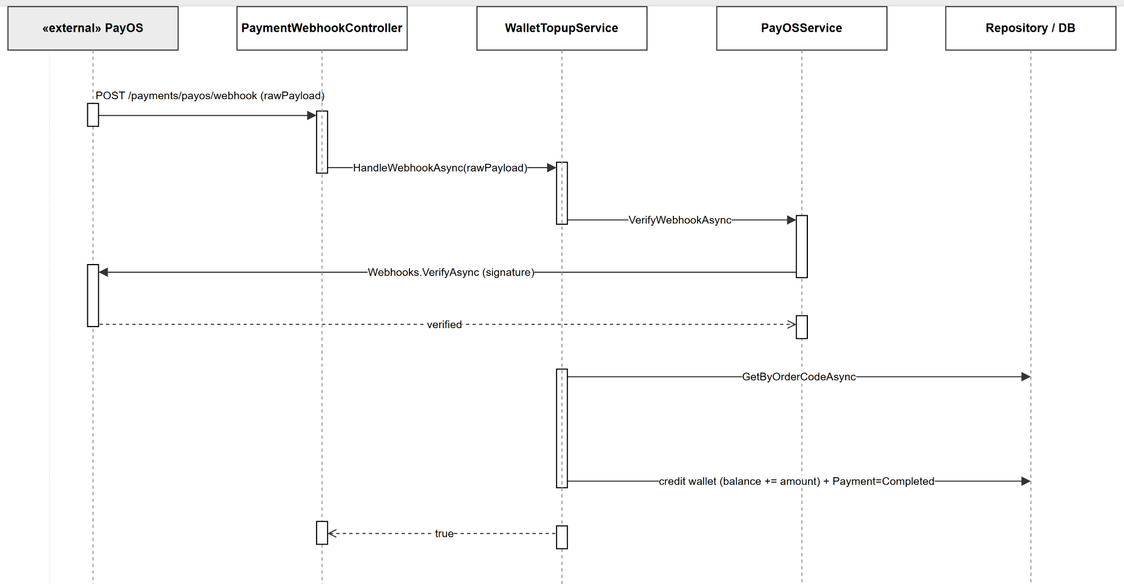
Figure 2-2-3. Payment Confirmation — Sequence Diagram

2.3 Document Ingest

2.3.1 Class Diagram
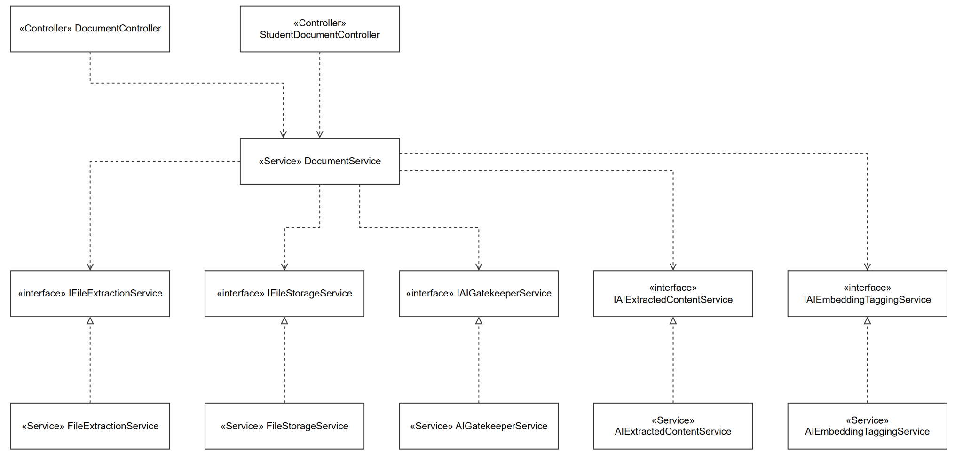
Figure 2-3-1. Document Ingest — Class Diagram

Class | Type | Layer | Note
DocumentController | Controller | API | /api/admin/documents/*
StudentDocumentController | Controller | API | /api/student/documents/*
DocumentService | Service | Application | Ingest orchestration
IFileExtractionService → FileExtractionService | Service | Application | PDF/text extraction (PdfPig)
IFileStorageService → FileStorageService | Service | Infrastructure/Services | Azure Blob; → IOptions<AzureBlobStorageOptions>
IAIGatekeeperService → AIGatekeeperService | Service | Application | → AI runtime set (2.0.2)
IAIExtractedContentService → AIExtractedContentService | Service | Application | → AI runtime set (2.0.2)
IAIEmbeddingTaggingService → AIEmbeddingTaggingService | Service | Application | → IAIExecutionService, IAIFeatureRoutingService, IAITagTaxonomyProvider
IDocumentRepository, IKnowledgeChunkRepository, IAIExtractionDraftRepository | Repositories | Infrastructure | —
Document, KnowledgeChunk, DocumentChapterSummary | Entities | Domain | —

2.3.2 Sequence Diagram — BYOS Upload and Ingest
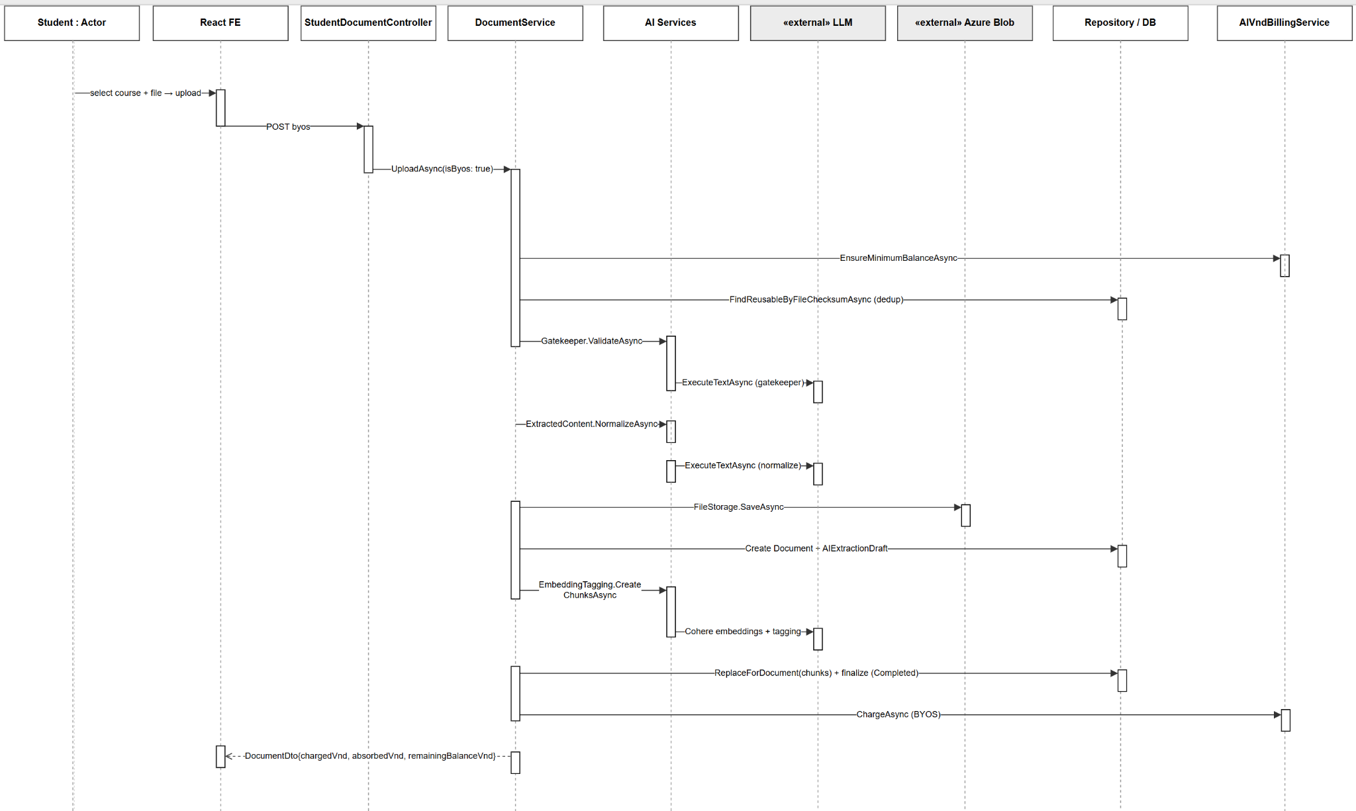
Figure 2-3-3. BYOS Upload — Sequence Diagram

2.4 Question Generation

2.4.1 Class Diagram
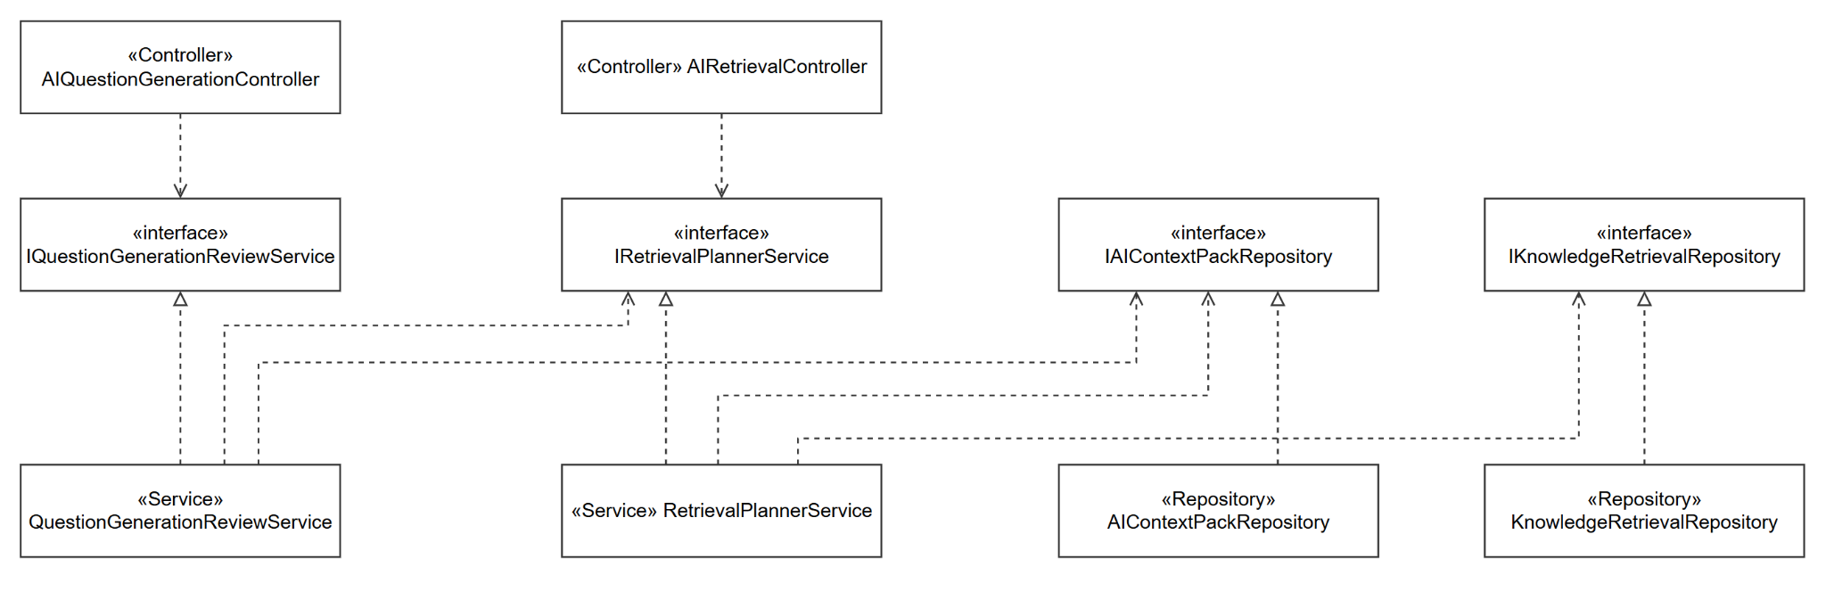
Figure 2-4-1. Question Generation — Class Diagram

Class | Type | Layer | Note
AIQuestionGenerationController | Controller | API | /api/ai/questions/*
AIRetrievalController | Controller | API | Retrieval plan
IQuestionGenerationReviewService → QuestionGenerationReviewService | Service | Application | Generation + review
IRetrievalPlannerService → RetrievalPlannerService | Service | Application | Context retrieval/pack; owned here, reused by Document Ingest
IAIContextPackRepository → AIContextPackRepository | Repository | Infrastructure | —
IKnowledgeRetrievalRepository → KnowledgeRetrievalRepository | Repository | Infrastructure | —
AIContextPack, KnowledgeChunk | Entities | Domain | KnowledgeChunk reused from Document Ingest

2.4.2 Sequence Diagram — Generate and Review
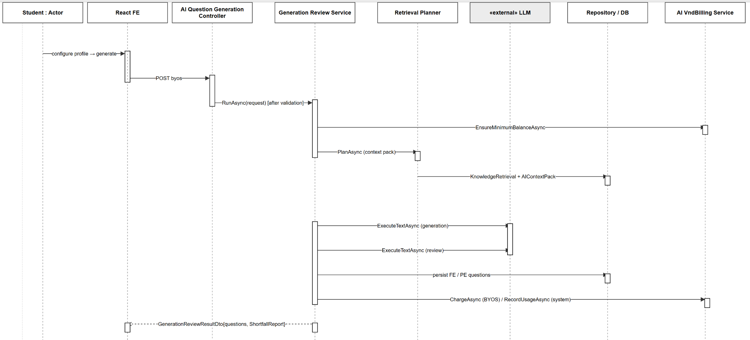
Figure 2-4-2. Generate and Review — Sequence Diagram

2.5 MCQ / Flashcard Practice

2.5.1 Class Diagram
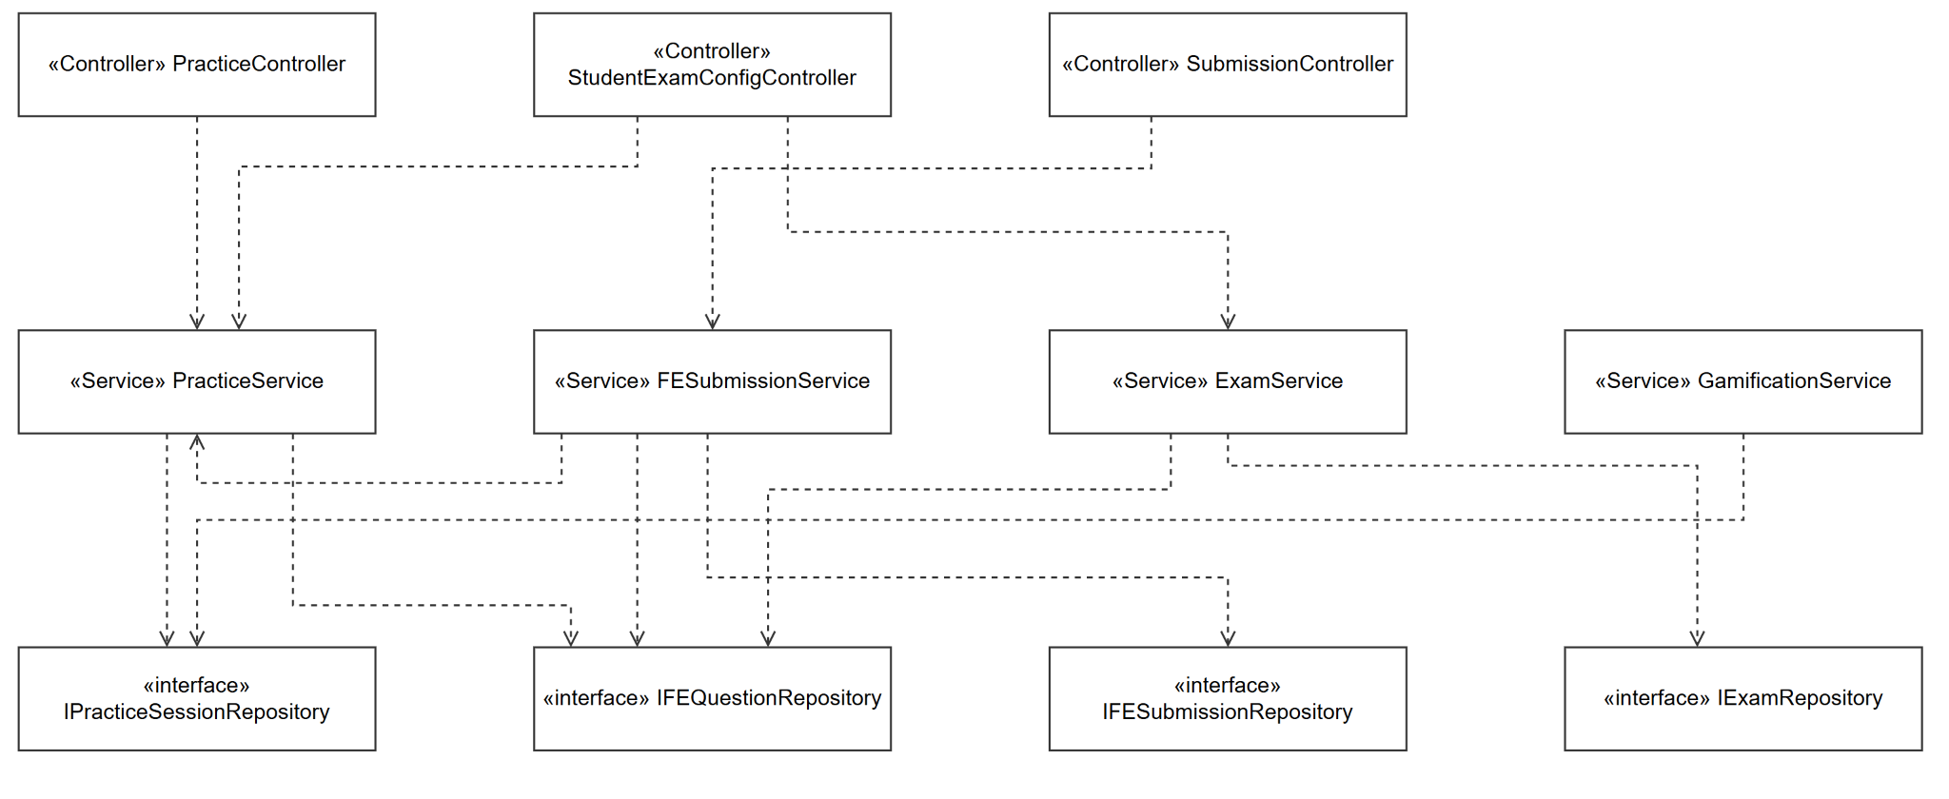
Figure 2-5-1. MCQ / Flashcard Practice — Class Diagram

Class | Type | Layer | Note
FEQuestionController, PracticeController, StudentExamController, StudentExamConfigController, StudentQuestionBankController, StudentGamificationController, StudentAnalyticsController | Controllers | API | MCQ bank, sessions, exams, config, question bank, streaks/analytics
PracticeService | Service | Application | Sessions
FESubmissionService | Service | Application | MCQ grading
ExamService | Service | Application | Exam build
GamificationService | Service | Application | → IMemoryCache
QuestionImportService | Service | Application | Excel import (ClosedXML)
IExamRepository, IPracticeSessionRepository, IFEQuestionRepository, IFESubmissionRepository | Repositories | Infrastructure | FEQuestionRepository owned here, reused by Question Generation
Exam, PracticeSession, FEQuestion, FE_Submission, DailyPracticeSummary | Entities | Domain | —

2.5.2 Sequence Diagram — Start and Answer MCQ
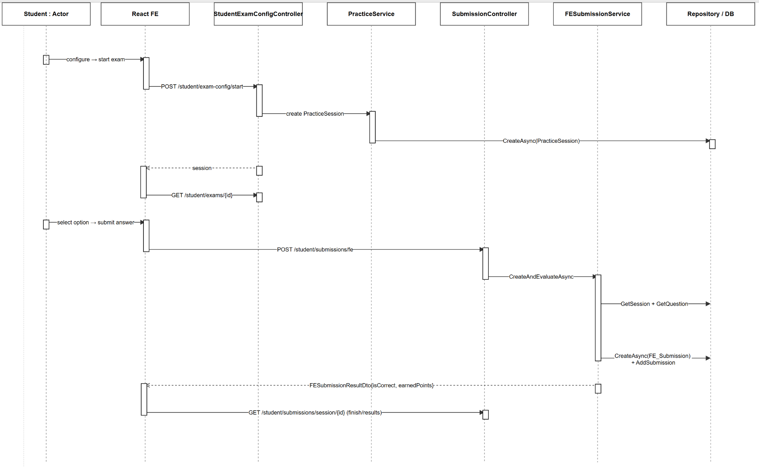
Figure 2-5-2. Start and Answer MCQ — Sequence Diagram

2.6 Coding Practice & Judge0

2.6.1 Class Diagram
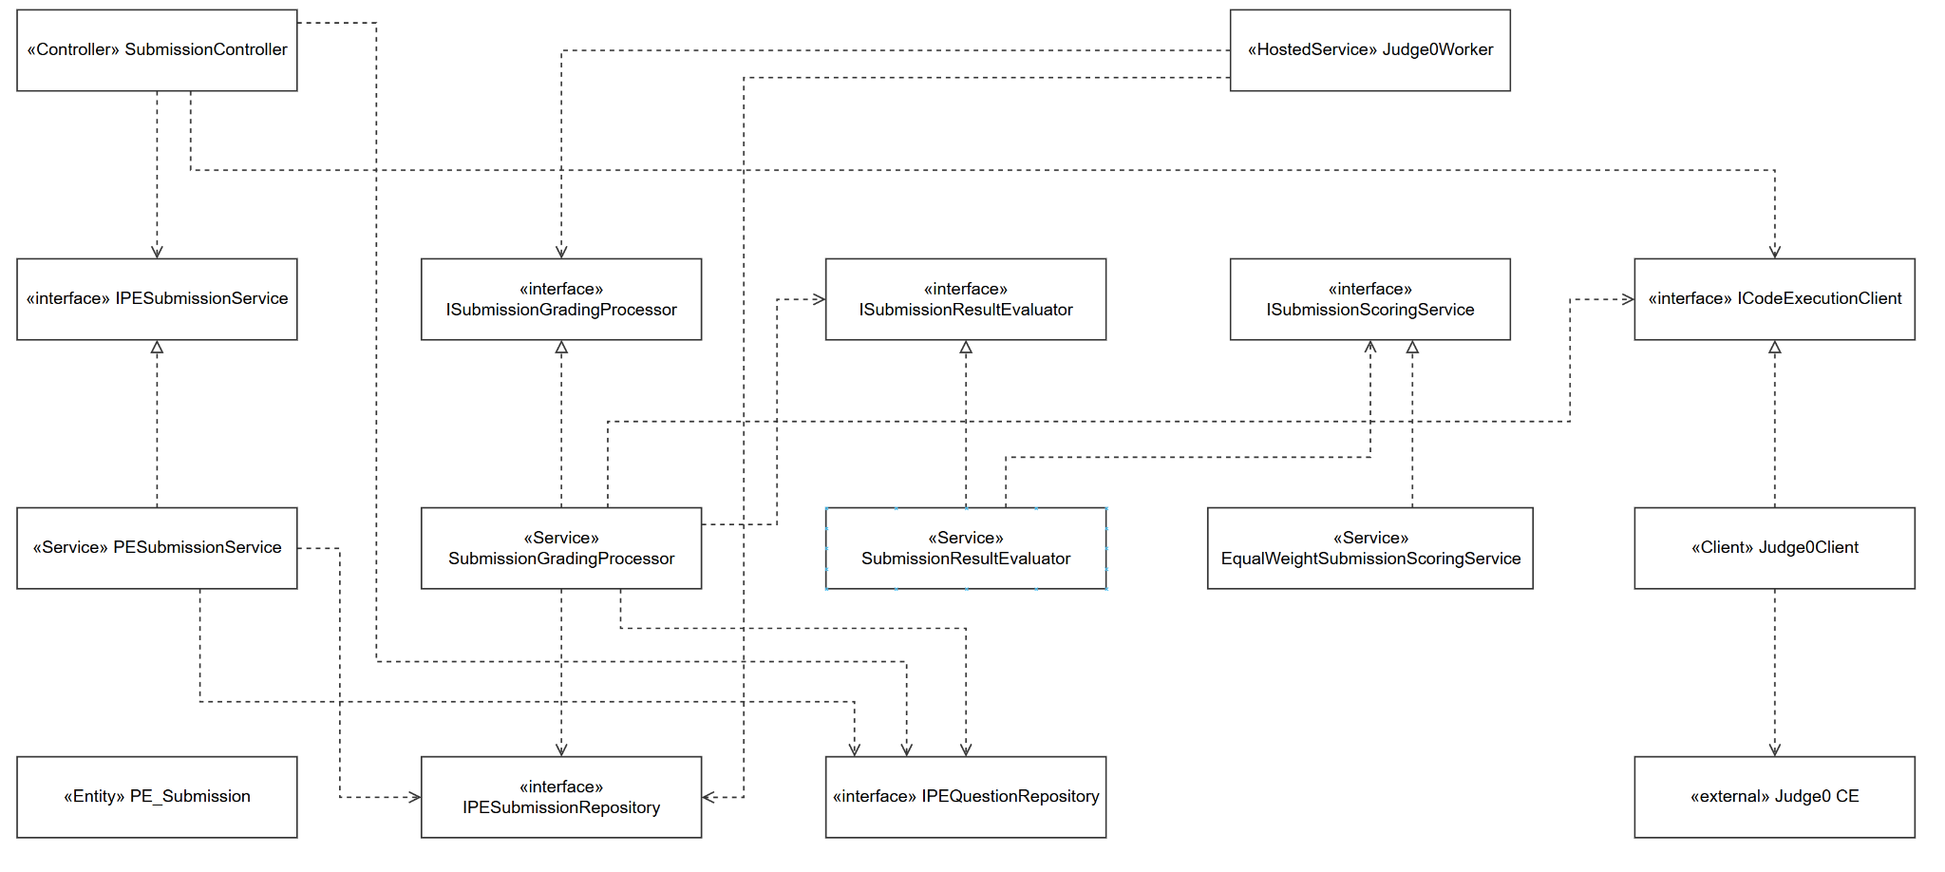
Figure 2-6-1. Coding Practice & Judge0 — Class Diagram

Class | Type | Layer | Note
SubmissionController | Controller | API | /api/student/submissions/* (fe, pe, pe/run, results, mentor)
IPESubmissionService → PESubmissionService | Service | Application | Submit / accept PE
ISubmissionGradingProcessor → SubmissionGradingProcessor | Service | Application | Grading orchestration
ISubmissionResultEvaluator → SubmissionResultEvaluator | Service | Application | Verdict/score mapping
ISubmissionScoringService → EqualWeightSubmissionScoringService | Service | Application | Scoring (stateless)
ICodeExecutionClient → Judge0Client | Client (typed HttpClient) | Infrastructure/Judge0 | → HttpClient, IOptions<Judge0Options>, IJudge0SourcePackageBuilder, ILogger
Judge0SourcePackageBuilder, Judge0MultiFileProfileResolver, Judge0OptionsValidator | Support | Infrastructure/Judge0 | —
Judge0Worker | HostedService | API/Workers | → IServiceScopeFactory, IOptions<GradingWorkerOptions>, TimeProvider, ILogger
IPESubmissionRepository, IPEQuestionRepository | Repositories | Infrastructure | Owned here, reused by AI Mentor and Question Generation
PE_Submission, PEQuestion, CodeFile, TestCase, ExecutionTracking | Entities | Domain | —
.

2.6.2 Sequence Diagram — Run Sample (Synchronous)
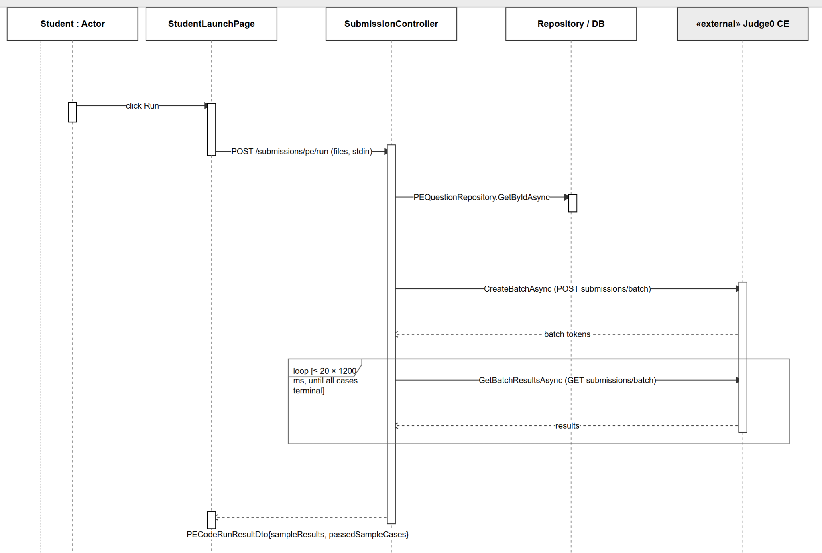
Figure 2-6-2. Run Sample — Sequence Diagram

2.6.3 Sequence Diagram — Submit and Grade (Asynchronous)
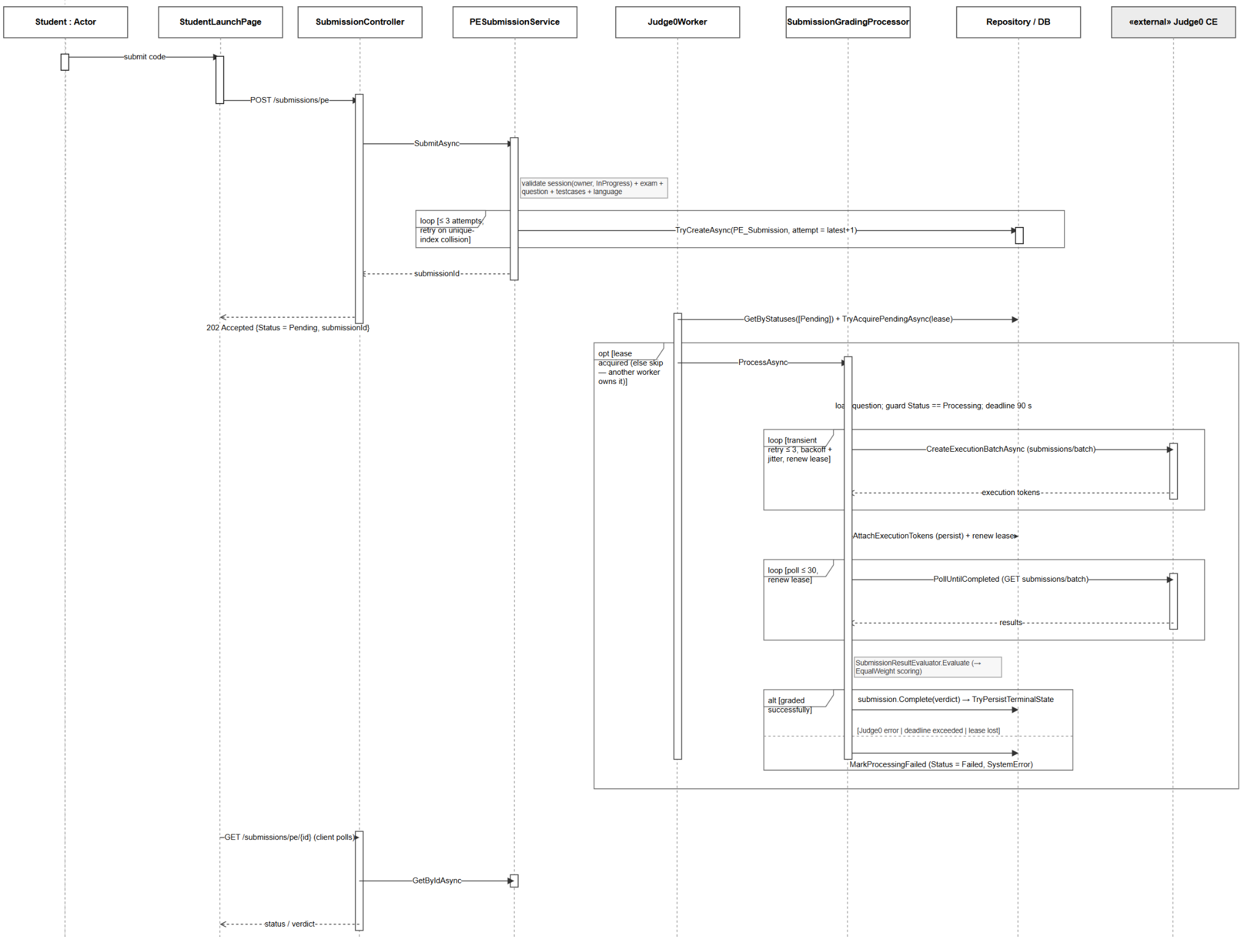
Figure 2-6-3. Submit and Grade — Sequence Diagram

2.7 AI Mentor

2.7.1 Class Diagram
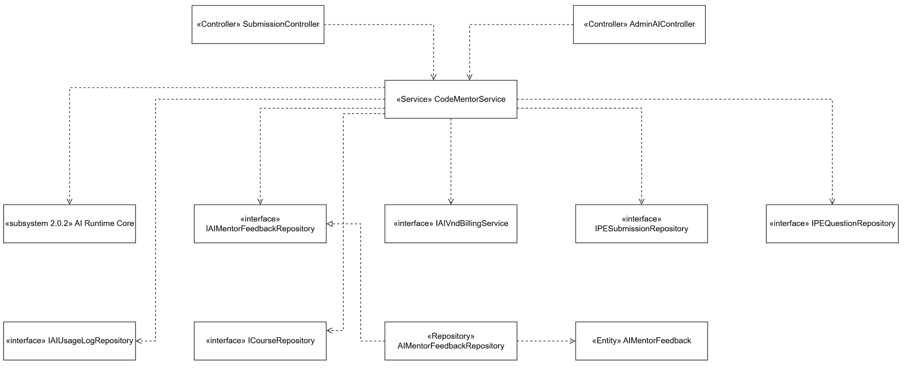
Figure 2-7-1. AI Mentor — Class Diagram

Class | Type | Layer | Note
CodeMentorService | Service | Application | Mentor feedback on PE submissions
IAIMentorFeedbackRepository → AIMentorFeedbackRepository | Repository | Infrastructure | —
AIMentorFeedback (+ MentorQualityScore, MentorErrorAnalysisItem, MentorImprovementSuggestion, MentorPerformanceSummary) | Entity | Domain | —

2.7.2 Sequence Diagram — Request Mentor Feedback
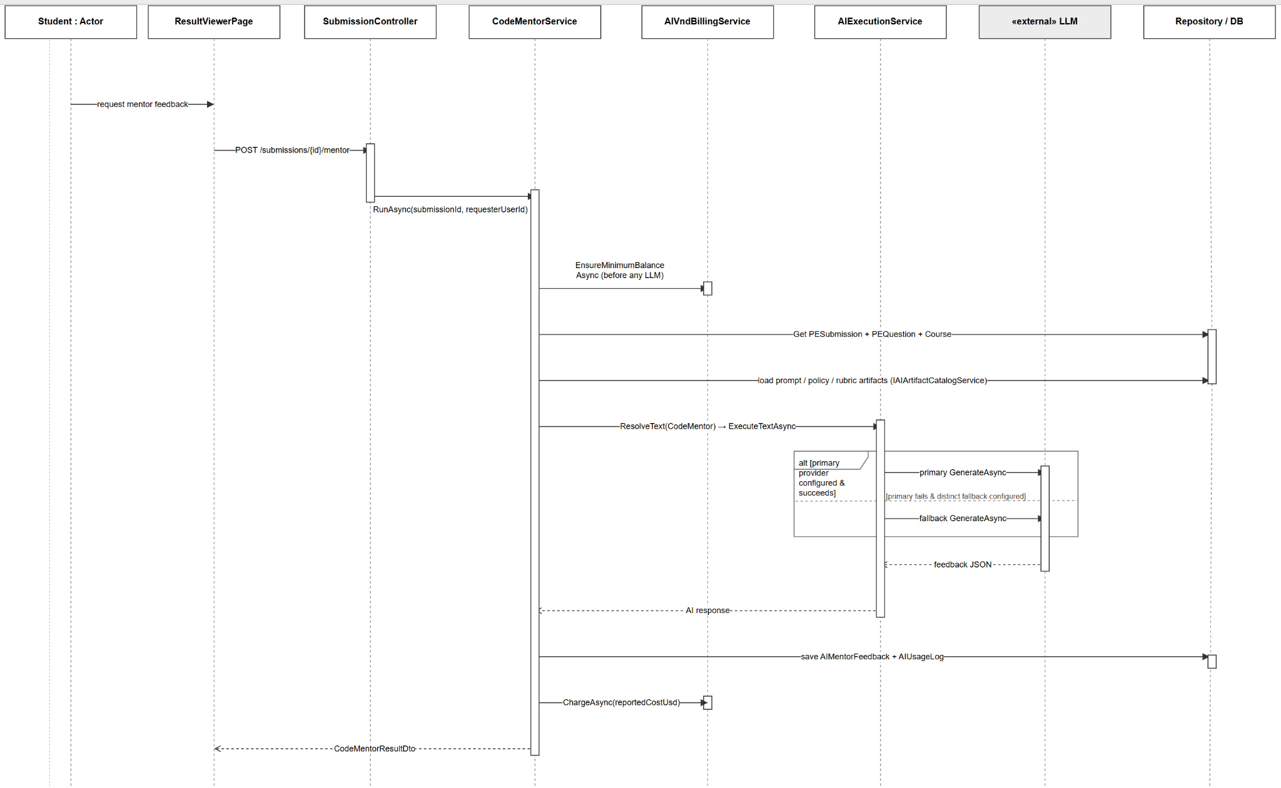
Figure 2-7-3. Request Mentor Feedback — Sequence Diagram

2.8 Draft Review

2.8.1 Class Diagram
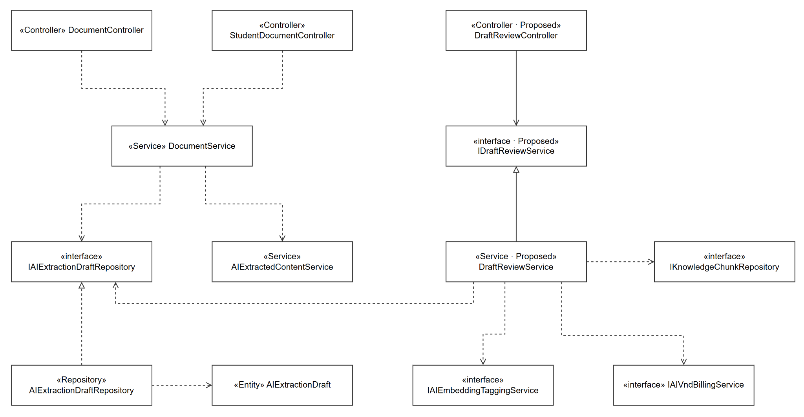
Figure 2-8-1. Draft Review — Class Diagram
Human review of the AIExtractionDraft produced during Document Ingest. Reuses the ingest pipeline; the distinct artifacts are the draft entity/repository and its review-status fields.

Class | Type | Layer | Note
IAIExtractionDraftRepository → AIExtractionDraftRepository | Repository | Infrastructure | Reused from Document Ingest
AIExtractedContentService | Service | Application | Reused from Document Ingest
AIExtractionDraft (+ ExtractionPricingBasisSnapshot) | Entity | Domain | Review fields: ReviewStatus, ReviewedBy, ApprovalVersion

2.8.2 Sequence Diagram — View Extraction Draft
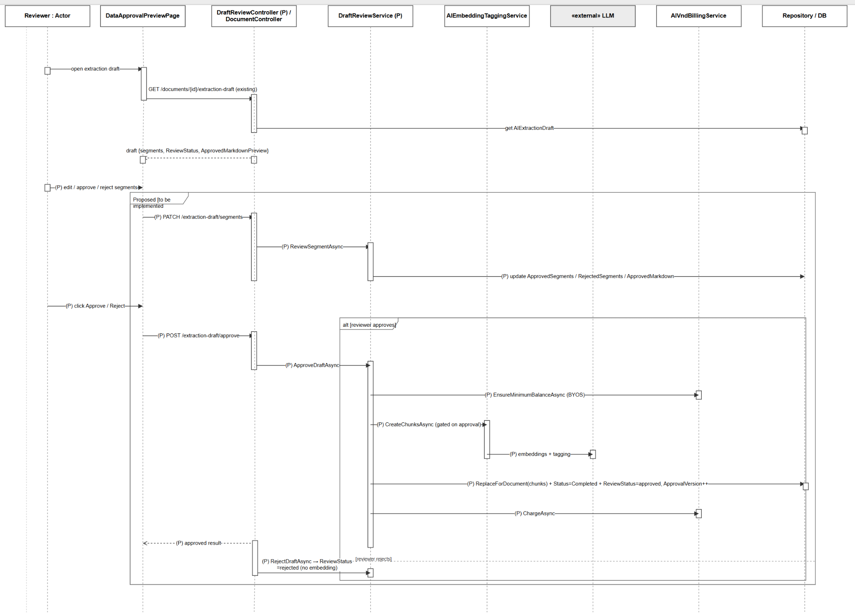
Figure 2-8-2. View Extraction Draft — Sequence Diagram

2.9 AI Configuration

2.9.1 Class Diagram
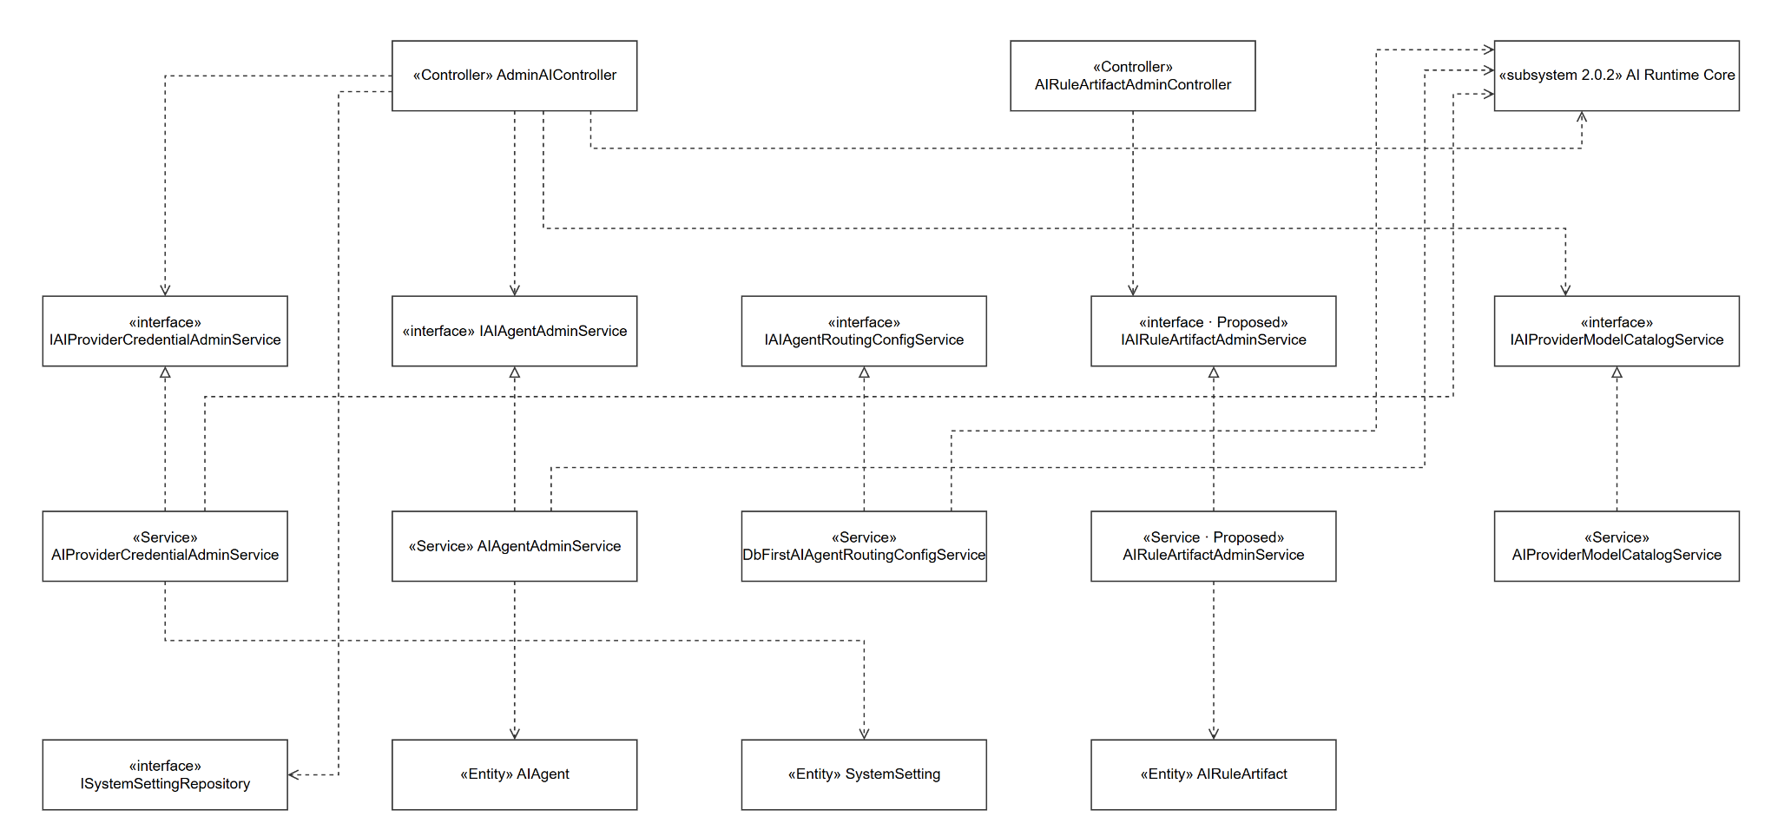
Figure 2-9-1. AI Configuration — Class Diagram

Class | Type | Layer | Note
AdminAIController | Controller | API | Admin AI operations hub
AIRuleArtifactAdminController | Controller | API | Rule/prompt artifact admin; → DbContext directly
IAIProviderCredentialAdminService → AIProviderCredentialAdminService | Service | Infrastructure/Services | → DbContext, IAIProviderSettingsResolver, IAISecretProtector
IAIAgentAdminService → AIAgentAdminService | Service | Infrastructure/Services | → DbContext, IAIProviderSettingsResolver
IAIAgentRoutingConfigService → DbFirstAIAgentRoutingConfigService | Service | Infrastructure/Services | → DbContext
IAIProviderModelCatalogService → AIProviderModelCatalogService | Service (typed HttpClient) | Infrastructure/Services | → HttpClient, IAIProviderSettingsResolver
Shared AI Runtime Core (2.0.2) | Services/clients | mixed | Configured here
AIAgent, AIRuleArtifact (+ AIRuleArtifactScope), SystemSetting | Entities | Domain | —
ISystemSettingRepository → SystemSettingRepository | Repository | Infrastructure | —

2.9.2 Sequence Diagram — Provider Credentials and Runtime Configuration
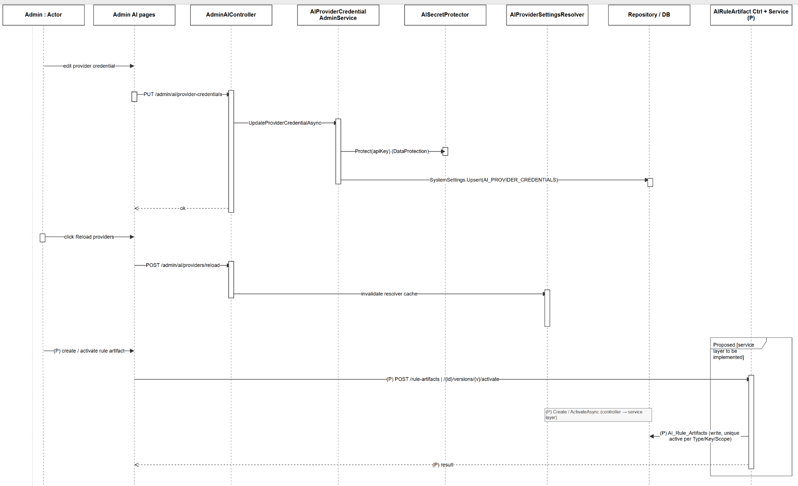
Figure 2-9-2. AI Configuration — Sequence Diagram

3. Class Specifications

3.1 Application.Services
This section provides the detailed specifications for the classes in the package Application.Services.

3.1.1 DocumentService
Orchestrates the document ingestion pipeline (validate, gatekeep, extract, normalize, store, chunk, embed) and serves document queries.
No | Name | Description
Attributes
01 | _repo | Visibility: private  Type: IDocumentRepository  Purpose: document persistence
02 | _courseRepo | Visibility: private  Type: ICourseRepository  Purpose: course lookup
03 | _userRepo | Visibility: private  Type: IUserRepository  Purpose: user lookup
04 | _extractor | Visibility: private  Type: IFileExtractionService  Purpose: raw text extraction from PDF/text
05 | _extractedContentService | Visibility: private  Type: IAIExtractedContentService  Purpose: AI content normalization
06 | _gatekeeper | Visibility: private  Type: IAIGatekeeperService  Purpose: AI content gatekeeping
07 | _embeddingTaggingService | Visibility: private  Type: IAIEmbeddingTaggingService  Purpose: chunk, embed, and tag content
08 | _chunkRepo | Visibility: private  Type: IKnowledgeChunkRepository  Purpose: knowledge-chunk persistence
09 | _draftRepo | Visibility: private  Type: IAIExtractionDraftRepository  Purpose: extraction-draft persistence
10 | _aiUsageLogRepository | Visibility: private  Type: IAIUsageLogRepository  Purpose: AI usage logging
11 | _vndBillingService | Visibility: private  Type: IAIVndBillingService  Purpose: AI wallet billing
12 | _fileStorage | Visibility: private  Type: IFileStorageService  Purpose: blob file storage
13 | _logger | Visibility: private  Type: ILogger  Purpose: logging
Methods/Operations
01 | UploadAsync | Visibility: public  Return: Task<DocumentDto>  Purpose: run the full ingestion pipeline for one document  Parameters:  - fileStream: Stream, the uploaded file  - fileName: string, original file name  - userId: string, uploader  - courseId: string, owning course  - isByos: bool, personal (BYOS) vs system source  - extractedContentRuntimeOverride: AIRuntimeOverride?, optional model override  - ct: CancellationToken
02 | GetByIdAsync | Visibility: public  Return: Task<Document?>  Purpose: fetch a document by id  Parameters:  - id: string, document id
03 | GetPreviewAsync | Visibility: public  Return: Task<DocumentPreviewResultDto?>  Purpose: return a content preview  Parameters:  - id: string, document id  - userId: string, requester  - isAdmin: bool, admin scope
04 | GetExtractionDraftAsync | Visibility: public  Return: Task<ExtractionDraftDto?>  Purpose: return the extraction-draft projection  Parameters:  - documentId: string  - requesterId: string  - isAdmin: bool
05 | ListByUserAsync | Visibility: public  Return: Task<PaginatedResult<DocumentListItemDto>>  Purpose: list a user's personal documents  Parameters:  - userId: string  - page: int  - limit: int
06 | ListSystemAsync | Visibility: public  Return: Task<PaginatedResult<DocumentListItemDto>>  Purpose: list system documents  Parameters:  - page: int  - limit: int  - courseId: string?, optional filter
07 | EditContentAsync | Visibility: public  Return: Task  Purpose: replace stored content  Parameters:  - id: string  - newContent: string  - adminId: string
08 | ToggleActiveAsync | Visibility: public  Return: Task  Purpose: activate/deactivate a document  Parameters:  - documentId: string
09 | DeleteByStudentAsync | Visibility: public  Return: Task  Purpose: soft-delete a personal document  Parameters:  - documentId: string  - userId: string  - ct: CancellationToken
10 | DeleteByAdminAsync | Visibility: public  Return: Task  Purpose: soft-delete a system document  Parameters:  - documentId: string  - adminId: string  - ct: CancellationToken
11 | OpenFileReadAsync | Visibility: public  Return: Task<Stream?>  Purpose: open the stored blob for reading  Parameters:  - relativePath: string  - ct: CancellationToken
12 | FileExistsAsync | Visibility: public  Return: Task<bool>  Purpose: check blob existence  Parameters:  - relativePath: string  - ct: CancellationToken

3.1.2 AIGatekeeperService
Validates whether extracted content is supported and on-subject before ingestion continues.
No | Name | Description
Attributes
01 | _aiExecutionService | Visibility: private  Type: IAIExecutionService  Purpose: LLM execution
02 | _routingService | Visibility: private  Type: IAIFeatureRoutingService  Purpose: feature → provider/model routing
03 | _promptService | Visibility: private  Type: IAIPromptService  Purpose: prompt rendering
04 | _artifactCatalogService | Visibility: private  Type: IAIArtifactCatalogService  Purpose: prompt/policy catalog
05 | _options | Visibility: private  Type: AIOptions  Purpose: AI runtime configuration
06 | _logger | Visibility: private  Type: ILogger  Purpose: logging
Methods/Operations
01 | ValidateAsync | Visibility: public  Return: Task<GatekeeperResult>  Purpose: gate content by subject/support  Parameters:  - content: string, extracted preview  - context: GatekeeperRequestContext?, expected subject/course  - ct: CancellationToken

3.1.3 AIExtractedContentService
Normalizes and structures extracted raw text into clean markdown for chunking.
No | Name | Description
Attributes
01 | _aiExecutionService | Visibility: private  Type: IAIExecutionService  Purpose: LLM execution
02 | _routingService | Visibility: private  Type: IAIFeatureRoutingService  Purpose: feature → provider/model routing
03 | _promptService | Visibility: private  Type: IAIPromptService  Purpose: prompt rendering
04 | _artifactCatalogService | Visibility: private  Type: IAIArtifactCatalogService  Purpose: prompt/policy catalog
05 | _options | Visibility: private  Type: AIOptions  Purpose: AI runtime configuration
06 | _logger | Visibility: private  Type: ILogger  Purpose: logging
Methods/Operations
01 | NormalizeAsync | Visibility: public  Return: Task<ExtractedContentResultDto>  Purpose: normalize/structure extracted content  Parameters:  - extracted: ExtractionResultDto, raw extraction  - runtimeOverride: AIRuntimeOverride?, optional model override  - ct: CancellationToken

3.1.4 AIEmbeddingTaggingService
Splits normalized content into knowledge chunks, then embeds and tags them.
No | Name | Description
Attributes
01 | _aiExecutionService | Visibility: private  Type: IAIExecutionService  Purpose: embedding execution
02 | _routingService | Visibility: private  Type: IAIFeatureRoutingService  Purpose: feature → provider/model routing
03 | _tagTaxonomyProvider | Visibility: private  Type: IAITagTaxonomyProvider  Purpose: topic-tag taxonomy
04 | _options | Visibility: private  Type: AIOptions  Purpose: AI runtime configuration
05 | _logger | Visibility: private  Type: ILogger  Purpose: logging
Methods/Operations
01 | CreateChunksAsync | Visibility: public  Return: Task<EmbeddingTaggingRunResult>  Purpose: chunk, embed, and tag document content  Parameters:  - documentId: string  - courseId: string  - userId: string  - content: string, normalized content  - sourceType: string  - subjectCode: string  - hints: ExtractionStructuralHintsDto, chapter/structure hints  - ct: CancellationToken

3.1.5 AIExecutionService
Dispatches text and embedding requests to the resolved LLM provider with automatic fallback.
No | Name | Description
Attributes
01 | _clientFactory | Visibility: private  Type: IAIClientFactory  Purpose: resolve LLM client by provider
02 | _options | Visibility: private  Type: AIOptions  Purpose: AI runtime configuration
03 | _logger | Visibility: private  Type: ILogger  Purpose: logging
Methods/Operations
01 | ExecuteTextAsync | Visibility: public  Return: Task<AITextResponse>  Purpose: run a text request with primary→fallback chain  Parameters:  - resolved: AIResolvedExecutionOptions, resolved provider/model  - request: AITextRequest, prompt payload  - ct: CancellationToken
02 | ExecuteEmbeddingAsync | Visibility: public  Return: Task<AIEmbeddingResponse>  Purpose: run an embedding request with fallback  Parameters:  - resolved: AIResolvedExecutionOptions, resolved provider/model  - request: AIEmbeddingRequest, embedding payload  - ct: CancellationToken

3.1.6 QuestionGenerationReviewService
Generates questions from a context pack, reviews them with the LLM, persists, and bills.
No | Name | Description
Attributes
01 | _aiExecutionService | Visibility: private  Type: IAIExecutionService  Purpose: LLM execution
02 | _routingService | Visibility: private  Type: IAIFeatureRoutingService  Purpose: feature → provider/model routing
03 | _promptService | Visibility: private  Type: IAIPromptService  Purpose: prompt rendering
04 | _artifactCatalogService | Visibility: private  Type: IAIArtifactCatalogService  Purpose: generation/review prompt catalog
05 | _contextPackRepository | Visibility: private  Type: IAIContextPackRepository  Purpose: context-pack persistence
06 | _retrievalPlannerService | Visibility: private  Type: IRetrievalPlannerService  Purpose: context retrieval and packing
07 | _documentRepository | Visibility: private  Type: IDocumentRepository  Purpose: source document lookup
08 | _feQuestionRepository | Visibility: private  Type: IFEQuestionRepository  Purpose: MCQ question persistence
09 | _peQuestionRepository | Visibility: private  Type: IPEQuestionRepository  Purpose: coding question persistence
10 | _aiUsageLogRepository | Visibility: private  Type: IAIUsageLogRepository  Purpose: AI usage logging
11 | _vndBillingService | Visibility: private  Type: IAIVndBillingService  Purpose: AI wallet billing
12 | _logger | Visibility: private  Type: ILogger  Purpose: logging
Methods/Operations
01 | RunAsync | Visibility: public  Return: Task<GenerationReviewResultDto>  Purpose: generate and review questions end to end  Parameters:  - request: GenerationReviewRequestDto, generation configuration  - ct: CancellationToken

3.1.7 RetrievalPlannerService
Retrieves grounded chunks, builds or reuses context packs, and produces topic/chapter summaries.
No | Name | Description
Attributes
01 | _knowledgeRetrievalRepository | Visibility: private  Type: IKnowledgeRetrievalRepository  Purpose: chunk retrieval queries
02 | _contextPackRepository | Visibility: private  Type: IAIContextPackRepository  Purpose: context-pack persistence
03 | _documentRepository | Visibility: private  Type: IDocumentRepository  Purpose: source document lookup
04 | _tagTaxonomyProvider | Visibility: private  Type: IAITagTaxonomyProvider  Purpose: topic-tag taxonomy
Methods/Operations
01 | PlanAsync | Visibility: public  Return: Task<RetrievalPlanResultDto>  Purpose: build or reuse a context pack for generation  Parameters:  - request: RetrievalPlanRequestDto, retrieval configuration  - ct: CancellationToken
02 | GetSystemSourceDocumentsAsync | Visibility: public  Return: Task<List<GenerationSourceDocumentDto>>  Purpose: list system source documents  Parameters:  - userId: string  - courseId: string  - ct: CancellationToken
03 | GetSystemTopicSummaryAsync | Visibility: public  Return: Task<TopicSummaryResultDto>  Purpose: summarize topics for a course  Parameters:  - userId: string  - courseId: string  - ct: CancellationToken
04 | GetSystemDocumentChapterTopicSummaryAsync | Visibility: public  Return: Task<TopicSummaryResultDto>  Purpose: topic summary for one chapter of a system document  Parameters:  - userId: string  - courseId: string  - documentId: string  - chapterKey: string  - ct: CancellationToken
05 | GetByosDocumentTopicSummaryAsync | Visibility: public  Return: Task<TopicSummaryResultDto>  Purpose: topic summary for a personal document  Parameters:  - userId: string  - documentId: string  - ct: CancellationToken
06 | GetContextPackAsync | Visibility: public  Return: Task<ContextPackDto?>  Purpose: fetch a context pack  Parameters:  - userId: string  - packId: string  - ct: CancellationToken
07 | ListContextPacksAsync | Visibility: public  Return: Task<List<ContextPackSummaryDto>>  Purpose: list a user's context packs  Parameters:  - userId: string  - subject: string?, optional filter  - questionType: string?, optional filter
08 | MarkStaleAsync | Visibility: public  Return: Task<ContextPackDto>  Purpose: mark a context pack stale  Parameters:  - userId: string  - packId: string  - ct: CancellationToken

3.1.8 ExamService
Creates, updates, and lists exams (presets) built from FE and PE questions.
No | Name | Description
Attributes
01 | _examRepo | Visibility: private  Type: IExamRepository  Purpose: exam persistence
02 | _feQuestionRepo | Visibility: private  Type: IFEQuestionRepository  Purpose: MCQ question lookup
03 | _peQuestionRepo | Visibility: private  Type: IPEQuestionRepository  Purpose: coding question lookup
Methods/Operations
01 | CreateExamAsync | Visibility: public  Return: Task<Exam>  Purpose: create an exam  Parameters:  - dto: CreateExamDto, exam definition
02 | UpdateExamAsync | Visibility: public  Return: Task<Exam>  Purpose: update an exam  Parameters:  - examId: string  - dto: CreateExamDto, new definition
03 | GetExamDetailByIdAsync | Visibility: public  Return: Task<ExamDetailDto?>  Purpose: fetch exam detail  Parameters:  - examId: string
04 | ListAsync | Visibility: public  Return: Task<(List<ExamDto>, long)>  Purpose: list exams by course  Parameters:  - courseId: string  - page: int  - limit: int
05 | ListAllAsync | Visibility: public  Return: Task<(List<ExamDto>, long)>  Purpose: list all exams  Parameters:  - page: int  - limit: int
06 | ListPublicAsync | Visibility: public  Return: Task<(List<ExamDto>, long)>  Purpose: list the public exam library  Parameters:  - courseId: string?, optional filter  - examType: string?, optional filter  - mode: string?, optional filter  - page: int  - limit: int
07 | ListOwnedAsync | Visibility: public  Return: Task<(List<ExamDto>, long)>  Purpose: list exams owned by a creator  Parameters:  - creatorUserId: string  - courseId: string?, optional filter  - page: int  - limit: int

3.1.9 PracticeService
Manages the practice-session lifecycle, draft code, history, and submission linking.
No | Name | Description
Attributes
01 | _sessionRepo | Visibility: private  Type: IPracticeSessionRepository  Purpose: session persistence
02 | _examRepo | Visibility: private  Type: IExamRepository  Purpose: exam lookup
03 | _courseRepo | Visibility: private  Type: ICourseRepository  Purpose: course lookup
04 | _userRepo | Visibility: private  Type: IUserRepository  Purpose: user lookup
05 | _feQuestionRepo | Visibility: private  Type: IFEQuestionRepository  Purpose: MCQ question lookup
06 | _peQuestionRepo | Visibility: private  Type: IPEQuestionRepository  Purpose: coding question lookup
07 | _feRepo | Visibility: private  Type: IFESubmissionRepository  Purpose: MCQ submission lookup
08 | _peRepo | Visibility: private  Type: IPESubmissionRepository  Purpose: coding submission lookup
Methods/Operations
01 | StartSessionAsync | Visibility: public  Return: Task<ApiResponse<StartSessionResultDto>>  Purpose: start or resume a practice session  Parameters:  - userId: string  - examId: string  - forceNew: bool, force a new session
02 | GetSessionAsync | Visibility: public  Return: Task<ApiResponse<PracticeSessionDto>>  Purpose: fetch a session  Parameters:  - sessionId: string
03 | EndSessionAsync | Visibility: public  Return: Task<ApiResponse<bool>>  Purpose: end a session  Parameters:  - sessionId: string
04 | PauseSessionAsync | Visibility: public  Return: Task<ApiResponse<bool>>  Purpose: pause a session  Parameters:  - userId: string  - sessionId: string
05 | ResumeSessionAsync | Visibility: public  Return: Task<ApiResponse<PracticeSessionDto>>  Purpose: resume a session  Parameters:  - userId: string  - sessionId: string
06 | SaveDraftCodeAsync | Visibility: public  Return: Task<ApiResponse<bool>>  Purpose: persist draft code for a question  Parameters:  - userId: string  - sessionId: string  - request: SaveDraftCodeDto, draft payload
07 | GetActiveSessionByExamAsync | Visibility: public  Return: Task<ApiResponse<ActivePracticeSessionSummaryDto?>>  Purpose: find the active session for an exam  Parameters:  - userId: string  - examId: string
08 | GetPracticeHistoryAsync | Visibility: public  Return: Task<ApiResponse<PaginatedResult<PracticeHistoryItemDto>>>  Purpose: paginated practice history  Parameters:  - userId: string  - page: int  - limit: int
09 | AddSubmissionAsync | Visibility: public  Return: Task<ApiResponse<bool>>  Purpose: link a submission to a session  Parameters:  - sessionId: string  - submissionId: string  - type: SubmissionType, FE or PE

3.1.10 FESubmissionService
Creates and grades multiple-choice submissions.
No | Name | Description
Attributes
01 | _feRepo | Visibility: private  Type: IFESubmissionRepository  Purpose: MCQ submission persistence
02 | _feQuestionRepo | Visibility: private  Type: IFEQuestionRepository  Purpose: MCQ question lookup
03 | _sessionRepo | Visibility: private  Type: IPracticeSessionRepository  Purpose: session lookup
04 | _practiceService | Visibility: private  Type: PracticeService  Purpose: submission-to-session linking
Methods/Operations
01 | CreateAndEvaluateAsync | Visibility: public  Return: Task<ApiResponse<FESubmissionResultDto>>  Purpose: grade an MCQ answer by set-equality  Parameters:  - userId: string  - dto: FESubmissionInputDto, session + question + answer
02 | GetByIdAsync | Visibility: public  Return: Task<ApiResponse<FESubmissionResultDto>>  Purpose: fetch one submission  Parameters:  - id: string
03 | GetBySessionAsync | Visibility: public  Return: Task<ApiResponse<List<FESubmissionResultDto>>>  Purpose: list submissions of a session  Parameters:  - sessionId: string

3.1.11 GamificationService
Computes dashboard summaries, streaks, badges, and leaderboards.
No | Name | Description
Attributes
01 | _userRepo | Visibility: private  Type: IUserRepository  Purpose: user lookup
02 | _sessionRepo | Visibility: private  Type: IPracticeSessionRepository  Purpose: session lookup
03 | _feSubmissionRepo | Visibility: private  Type: IFESubmissionRepository  Purpose: MCQ submission lookup
04 | _peSubmissionRepo | Visibility: private  Type: IPESubmissionRepository  Purpose: coding submission lookup
05 | _examRepo | Visibility: private  Type: IExamRepository  Purpose: exam lookup
06 | _memoryCache | Visibility: private  Type: IMemoryCache  Purpose: cache leaderboard/summary results
Methods/Operations
01 | GetSummaryAsync | Visibility: public  Return: Task<StudentSummaryDto?>  Purpose: dashboard summary  Parameters:  - userId: string
02 | GetStreakAsync | Visibility: public  Return: Task<StreakDto?>  Purpose: current/highest streak  Parameters:  - userId: string
03 | GetBadgesAsync | Visibility: public  Return: Task<List<BadgeDto>?>  Purpose: earned badges  Parameters:  - userId: string
04 | GetLeaderboardAsync | Visibility: public  Return: Task<List<LeaderboardEntryDto>>  Purpose: leaderboard ranking  Parameters:  - courseId: string?, optional scope  - scope: string, ranking scope  - currentUserId: string

3.1.12 QuestionImportService
Imports multiple-choice questions from an Excel workbook.
No | Name | Description
Attributes
01 | _feRepo | Visibility: private  Type: IFEQuestionRepository  Purpose: MCQ question persistence
02 | _courseRepo | Visibility: private  Type: ICourseRepository  Purpose: course lookup
03 | _logger | Visibility: private  Type: ILogger  Purpose: logging
Methods/Operations
01 | ImportFromExcelAsync | Visibility: public  Return: Task<ImportResultDto>  Purpose: parse a workbook and insert questions  Parameters:  - fileStream: Stream, the Excel file  - adminId: string, importer

3.1.13 PESubmissionService
Accepts coding submissions asynchronously and serves submission reads.
No | Name | Description
Attributes
01 | _submissionRepository | Visibility: private  Type: IPESubmissionRepository  Purpose: coding submission persistence
02 | _sessionRepository | Visibility: private  Type: IPracticeSessionRepository  Purpose: session lookup
03 | _examRepository | Visibility: private  Type: IExamRepository  Purpose: exam lookup
04 | _questionRepository | Visibility: private  Type: IPEQuestionRepository  Purpose: coding question lookup
05 | _idGenerator | Visibility: private  Type: IIdGenerator  Purpose: ObjectId generation
06 | AttemptAllocationRetryLimit | Visibility: private const  Type: int (= 3)  Purpose: max retries when allocating a unique attempt
Methods/Operations
01 | SubmitAsync | Visibility: public  Return: Task<ApiResponse<SubmissionAcceptedDto>>  Purpose: validate and create a Pending submission  Parameters:  - studentId: string  - request: PESubmissionInputDto, code + question  - ct: CancellationToken
02 | GetByIdAsync | Visibility: public  Return: Task<ApiResponse<PESubmissionDetailDto>>  Purpose: fetch submission detail/status  Parameters:  - studentId: string  - submissionId: string  - ct: CancellationToken
03 | GetBySessionAsync | Visibility: public  Return: Task<ApiResponse<IReadOnlyCollection<PESubmissionSummaryDto>>>  Purpose: list a session's submissions  Parameters:  - studentId: string  - sessionId: string  - ct: CancellationToken

3.1.14 SubmissionGradingProcessor
Grades one coding submission via Judge0 under a lease (batch, poll, evaluate).
No | Name | Description
Attributes
01 | _submissionRepository | Visibility: private  Type: IPESubmissionRepository  Purpose: coding submission persistence
02 | _questionRepository | Visibility: private  Type: IPEQuestionRepository  Purpose: coding question lookup
03 | _executionClient | Visibility: private  Type: ICodeExecutionClient  Purpose: Judge0 execution
04 | _resultEvaluator | Visibility: private  Type: ISubmissionResultEvaluator  Purpose: verdict/score evaluation
05 | _options | Visibility: private  Type: GradingWorkerOptions  Purpose: grading limits (attempts, polling, deadline)
06 | _timeProvider | Visibility: private  Type: TimeProvider  Purpose: clock abstraction for leases/deadlines
07 | _logger | Visibility: private  Type: ILogger  Purpose: logging
Methods/Operations
01 | ProcessAsync | Visibility: public  Return: Task  Purpose: grade a single submission end to end  Parameters:  - submissionId: string  - leaseOwner: string, worker id holding the lease  - ct: CancellationToken

3.1.15 SubmissionResultEvaluator
Maps Judge0 execution results to a verdict and score.
No | Name | Description
Attributes
01 | _scoringService | Visibility: private  Type: ISubmissionScoringService  Purpose: test-case scoring
Methods/Operations
01 | Evaluate | Visibility: public  Return: SubmissionEvaluation  Purpose: compute verdict and score from execution results  Parameters:  - question: PEQuestion, the graded question  - executionResults: IReadOnlyList<CodeExecutionResult>, per-test results  - maxScore: double, question max score

3.1.16 EqualWeightSubmissionScoringService
Scores a coding submission by assigning equal weight to each test case.
No | Name | Description
Attributes
-- | (none) | This class holds no state.
Methods/Operations
01 | Calculate | Visibility: public  Return: SubmissionEvaluation  Purpose: equal-weight score across test results  Parameters:  - testResults: IReadOnlyCollection<TestResultItem>, per-test outcomes  - maxScore: double, question max score

3.2 Infrastructure.Services
This section provides the detailed specifications for the classes in the package Infrastructure.Services.

3.2.1 FileStorageService
Stores and retrieves source document files in Azure Blob Storage.
No | Name | Description
Attributes
01 | _options | Visibility: private  Type: AzureBlobStorageOptions  Purpose: container/connection configuration (plus the blob client)
Methods/Operations
01 | SaveAsync | Visibility: public  Return: Task<string>  Purpose: upload a file and return its relative path  Parameters:  - stream: Stream, file content  - fileName: string, target name
02 | OpenReadAsync | Visibility: public  Return: Task<Stream?>  Purpose: download a file  Parameters:  - relativePath: string  - ct: CancellationToken
03 | ExistsAsync | Visibility: public  Return: Task<bool>  Purpose: check file existence  Parameters:  - relativePath: string  - ct: CancellationToken
04 | GetSizeAsync | Visibility: public  Return: Task<long?>  Purpose: get file size in bytes  Parameters:  - relativePath: string  - ct: CancellationToken
05 | DeleteAsync | Visibility: public  Return: Task<bool>  Purpose: delete a file  Parameters:  - relativePath: string  - ct: CancellationToken

3.3 Infrastructure.Judge0
This section provides the detailed specifications for the classes in the package Infrastructure.Judge0.

3.3.1 Judge0Client
REST client for the Judge0 code-execution engine (batch submit, poll, health check).
No | Name | Description
Attributes
01 | _httpClient | Visibility: private  Type: HttpClient  Purpose: HTTP transport to Judge0
02 | _options | Visibility: private  Type: Judge0Options  Purpose: endpoint, key, and limits configuration
03 | _packageBuilder | Visibility: private  Type: IJudge0SourcePackageBuilder  Purpose: build the source/test package for a submission
04 | _logger | Visibility: private  Type: ILogger  Purpose: logging
05 | ResultFields | Visibility: private const  Type: string  Purpose: fields requested from the Judge0 results endpoint
Methods/Operations
01 | CreateBatchAsync | Visibility: public  Return: Task<CodeExecutionBatchReceipt>  Purpose: submit a batch — POST submissions/batch  Parameters:  - request: CodeExecutionBatchRequest, code + test cases  - ct: CancellationToken
02 | GetBatchResultsAsync | Visibility: public  Return: Task<IReadOnlyList<CodeExecutionResult>>  Purpose: fetch results — GET submissions/batch  Parameters:  - tokens: IReadOnlyCollection<string>, submission tokens  - ct: CancellationToken
03 | IsHealthyAsync | Visibility: public  Return: Task<bool>  Purpose: health probe — GET languages  Parameters:  - ct: CancellationToken

